**Data Types**

1. **Some Number Types**

You can specify exponents using the e notation: 2.34e2 ~ 234

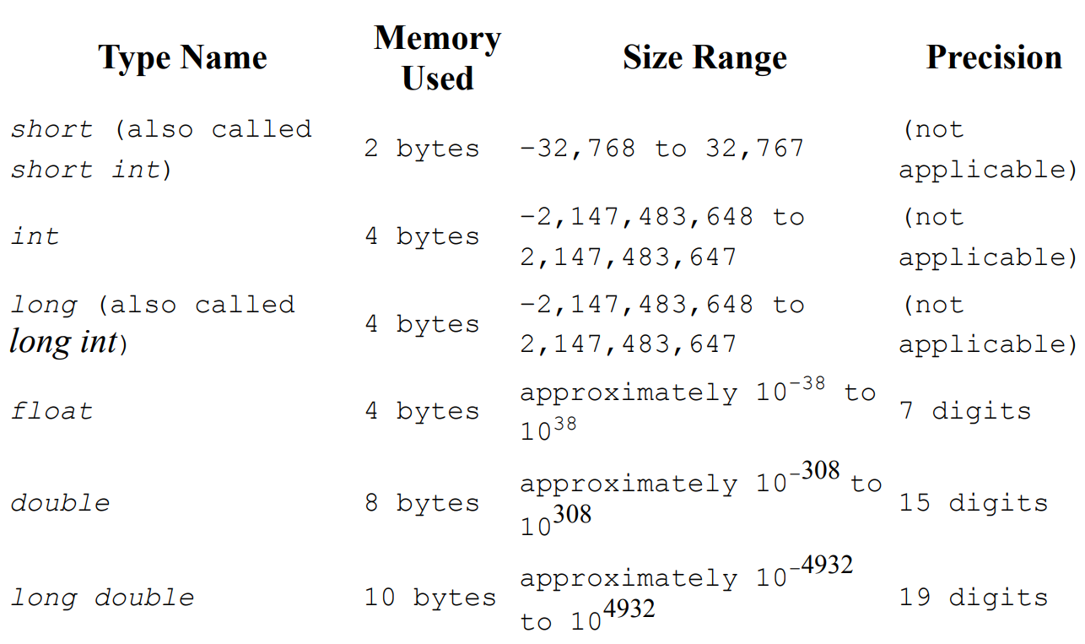

*Precision means the number of meaningful digits (significant figures)*

Note that for these number types, the size (memory used) **varies from one machine to another** (on 32-bit machines, int are 4 bytes, but on 64-bit machines, int are 8 bytes).

* To **specify decimal points**

cout.setf(ios::fixed);

cout.setf(ios::showpoint); 🡪 any cout statements after will output 2 decimal point

cout.precision(2); (only need last line if we want to change later)

* Arithmetic Operator

Regardless of +-*/, the rule follows:

int int 🡪 int 7/2 = 3 (int 🡪 truncated)

int float 🡪 float

float float 🡪 float

**Random Number Generator**

#include <cstdlib>

#include <ctime>

srand(time(NULL)); (called only 1 time, because the code will run faster than time passes

int dice = (rand() % 6) + 1; 🡪 same seed generated for the code)

**Type Cast**

static_cast <double> (*variable*)

OR double (*variable*) (but may be discontinued in later versions)

1. **Strings**

#include <string>

using namespace std;

**Some useful string methods:**

string str = "UofT"

string str2 = "HIHI"

|  |  |  |  |
| --- | --- | --- | --- |
| Method | Usage | Example | |
| str.push_back() | Inserts a char to end | str.push_back('!'); //UofT! | |
| Concatenate 2 strings | | | str = str1 + str2; | |
| str.pop_back() | Removes last char | str.pop_back(); //Uof | |
| str.size() /str.length() | Returns size | str.size(); //4 | |
| <str_src>.copy( <dest_char_arr>, <num>, <startpos>)  - Copies <num> numbers of characters from source string, starting at <startpos> index, to destination character array.  - Function returns the number of characters copied to the array | | | char buffer[20];  string str ("Test string...");  size_t length = str.copy(buffer,6,5);  buffer[length]='\0';  cout << "buffer contains: " << buffer << '\n'; | |
| str.swap(str2) | Swaps 2 strings | str.swap(str2);  cout<<str<<endl; //HIHI cout<<str2<<endl; //UofT | |
| str.resize(<size>) | Changes the length | str.resize(2); //Uo | |
| stoi( <string> ) | If the string starts with character, this will return error. | string s1 = "123"; int v1 = stoi(s1); cout<<v1<<endl; //123 string s2 = "123 pass"; int v2 = stoi(s2); cout<<v2; //123 | |
| str.compare(str2) | 0 --> equal  < 0 --> str < str2  > 0 --> str > str2 |  | |
| Relational operators | ==, != , <, <=, >, >= | // Included in #include <string> | |
| str.find(str2, int pos=0) | Returns first index of found str2.  Starts searching at & include pos.  If not found, return -1 |  | |
| str.append(str2, pos,len) | Appends len number of chars from str2 to the end of str1, starting from char at pos | string str;  string str3="print 10 and then 5 more";  str.append(str3,6,3); // "10 " | |
| str.insert(pos, str2, a, b) | Insert a->b of str2 **before** pos in str | string str="to be question";  string str3="or not to be";  str.insert(6,str3,3,4); // to be not question | |
| str.replace(pos,len,str2, a,b) | Replace portion of str, begin at pos & spans len with a -> b of new content | string base="this is a test string.";  string str2="n example";  string str3="sample phrase";  str.replace(9,5,str2);  // "this is an example string."  str.replace(19,6,str3,7,6);  // "this is an example phrase." | |
| str.erase(pos, len) | Erase content from pos, spans len | string str ("This is an example sentence.");  str.erase (10,8); "This is an sentence." | |
| str.substr(pos, len) | Returns substr size len, starts at pos | string str="We think in generalities";  string str2 = str.substr (3,5); // "think" | |

**Input/Output**

1. **Streams and Basic File I/O**

* The **type** for input-file and output-file stream variables are named ifstream and ofstream.
* These types are defined in the library #include <fstream>
* These types are also under namespace std.

**a) File Input**

|  |  |
| --- | --- |
| *ifstream* inFile ; or:  inFile.open ("file_directory") ; | ifstream inFile ("file_directory") |

**">>" skips all blank spaces, and will stop after getting enough data for the datatype of the variable**

**This may lead to unexpected errors. For example:**

|  |  |  |  |
| --- | --- | --- | --- |
| inFile | main.cpp | int a | float b |
| 3.2  2.6 | inFile >> a;  inFile >> b; | 3 | **0.2** |

**b) File output**

|  |  |
| --- | --- |
| *ofstream* outFile ; or:  outFile.open ("file_directory") ; | ofstream outFile ("file_directory") ; |

* Open for writing (default)
  + If file already exist, it is first erased.
  + Otherwise it is newly created.
* Open for append
  + outFile.open (“data.txt”, ios::app) ;
  + Writing adds to the end of the file

Now, our program can send output to the file using the insertion operator <<. For example:

outstream << “oneNumber = “ << oneNumber << “anotherNumber = “ << anotherNumber ;

Notice that after the file has been opened, *the file is then referred to by the stream*

? Why do we need to open the file? What if we instead just do write("filename") or append("filename")

🡪 Performance reason. Everytime we read/write/append, etc. to a file, there is a **permission check** needed to occur. Therefore, instead of doing this permisison check everytime, we do it once while opening the file.

? .open() returns file descripter (big data structure), containing info that we can operate on our file

🡪 Takes up a memory space.

🡪 Every file should be closed after working with, using the method .close()

inStream.close () ;

1. **Buffering**

Accessing Hard Drive/SSD is slower than accessing Memory (RAM), up to a couple thousand times. Therefore, if we do writing to files normally if we wait for the statement to actually hit the hard drive, and there will be a delay.

🡪 OS can do something smart to hide this slow latency from you. There is a space allocated in the memory by the OS, called a buffer, to act as an intermediate accessor. When we perform writing action, the statement will **immediately return**, before the actually data is written in the file.

The data on the buffer will be eventually written to the hard drive for safety during the operation. However, there are times where we might want the memory to be written directly to the hard drive (files), so we can use .flush() to force this action. **This will flush all data in the buffer of the specified outFile to the actual file.**

outFile.flush()

Note that even if after we call .flush(), this is only on the side of the OS, meaning it attempted to flush. There may be circumstances where the hard drive might not deliver. We have to accept that the writing and saving to file operation may sometimes fail.

**Therefore, what's the difference between \n and endl?**

**When using endl, we are telling the OS to flush (everything for that file) 🡪 Should use endl.**

**File Error Handling**

1. **File doesn't exist**

In case the file doesn't exist, or not opened correctly, .fail() returns true.

inStream.fail ()

As we add this statement to our program, we can **handle the error** detected:

* Return 1
* **Exit the program**, using the .exit(<Integer_Value>) function (#include stdlib)

By convention, 1 is used for a call to exit that is caused by an error, and 0 is used in other cases.

1. **Cannot read (data mismatch)**

Say we define int a

But the first character in the file is 'b'. This will also cause **type** **error**, .fail() returns true

1. **End of file** .eof()

When we reaches the end of a file while ( ! lineStream.eof() )

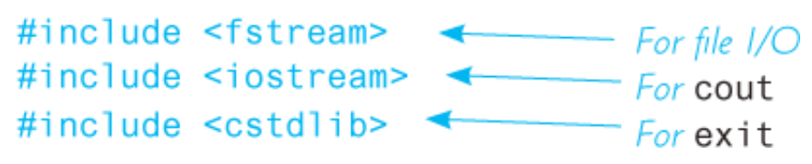

using namespace std;

int main() {

if (inFile.fail()){

cout << “Cannot open file: input.txt” << endl;

return 1;

}

inFile >> a;

if (inFile.fail()) {

cout << “Cannot read a!” << endl;

return 1; // Escapes the program when failed

}

inFile >> b;

if (inFile.fail()) {

cout << “Cannot read b!” << endl;

return 1;

}

cout << “a = “ << a << “, b = “ << b << endl;

return 0;

}

1. **Continue after error**

When we want to skip the error line, and then **try to read again**

.ignore(int num_of_chars, char delimiter)

* Discard num_of_chars characters, up to first delimiter, **which ever comes first**.

.clear()

* **Clear the error state flag** (allows continuous reading of data)
* If we do not clear the error flag, the **inFile.fail() we always return true. No operation on the stream will work**

inFile.open( "input.txt" ); if (inFile.fail()) { return 1; }. //Checks for error in opening file

while ( !inFile.eof() ) {

inFile >> a;

if (inFile.fail()) { **// This will set value of a back to 0!**

cout << "failed.." << endl;

inFile.clear(); // CRUCIAL

inFile.ignore(100, '\n');

continue;

}

cout << "a = " << a << endl;

}

return 0;

**Stringstream**

Stringstream helps us use a string as an I/O stream. Using this, we can use "<<" and ">>" operators to parse the input to fit the type of the variable.

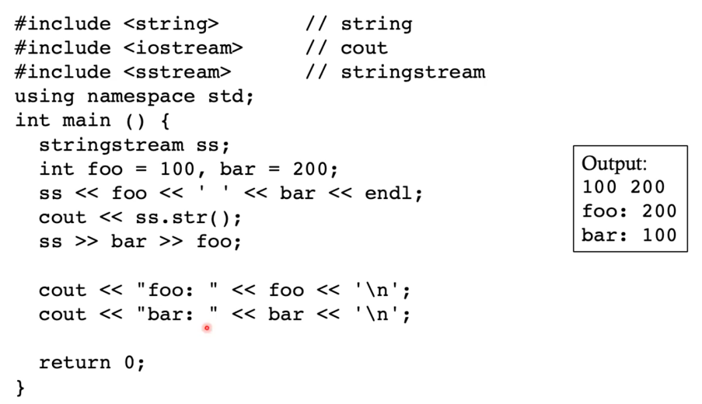

stringstream acts like a buffer, which "stores" the string inputs from input streams and can parse the output to variables, either if we want to extract strings or integers 🡪 stringstream does the work for us, and make it easier to detect bugs.

**\*\*\*\*\*\*\*\*\*\*\*\*\*\*\*\*\*\*\*\*\*\*\*\*\*\*\*\*\*\*\***

For example, we can get input from the user, put into a stringstream called "ss", and then extract the information to saved variables.

string cin_input;

**getline** (cin, cin_input); // store user input from cin into the string "cin_input"

stringstream ss(cin_input); // create a stringstream, adding cin_input to it. We can also do

// ss << cin_input;

string first, second;

int third;

ss >> first >> second >> third;

**Functions**

#include <iostream> 🡪 cin cout

#include <cmath> 🡪 sqrt pow fabs(double) ceil floor

**Function Overloading**

In the process of function overloading, you can *give multiple C++ functions the same name*. However, at least one of these conditions are true:

* Each has different type parameters.
* Each has a different number of parameters.

void print_input_twice (int num) { std::cout << num*2; }

void print_input_twice (char c) { std::cout << c+c; }

**Default value**

**Must always define default values in function declarations (in header file)**

**Note on const**

* Putting const when declaring a member function guarantees that function will not modify member variables.
* Putting const before a parameter guarantees that the function will not modify the argument passed (when passing by reference)

However, for example if the member function is defined as:

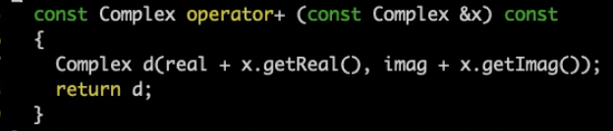

Note that we are using accessors .getReal() and .getImag(). Even though these functions do not modify the values of x, the compiler won't even go into the functions to check whether they are modifying the objects or not 🡪 Still an error (it thinks that we modified const Comples &x)

Therefore, **we should state that the accessor methods will not modify the objects**

🡪 adding const to the accessor definition

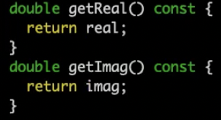

**Program Organization**

1. **Header Files** - contains declarations of function, data structures, class definition
2. **#include**

* Only #include header files
* Basically **copy** all the contents to the file, during pre-processing
* #include <iostream> for standard libraries. #include "linked_list.h" for user-defined files.
* Multiple files can #include a header 🡪 Header guards to avoid multiple declarations

**#ifndef HEADER_FILE_NAME**

**#define HEADER_FILE_NAME**

… (header file content)

**#endif**

1. **Compile & Execute**

There are 4 steps that needs to be taken:

|  |  |
| --- | --- |
| main.cpp | header.hpp |
| * Preprosessing * Compilation * Assembly   🡪 Object file .o | * Preprosessing * Compilation * Assembly   🡪 Object file .o |
| Linking all object files 🡪 Executable file | |

**Preprocessing**: Resolve all '#', copy paste every files and libraries included; remove comments 🡪 **.i file**

g++ -E main.cpp -o main_preprocessed.i

**Compilation**: Input: C++ langugage; Output: **assembly code**

g++ -S main_preprocessed.i -o main.S

**Assembly**: Input: assembly code; Output: **binary code** (machine code, object file)

g++ -c main.S -o main.o

Note: we can merge these 3 actions into 1 command, for compilation of each file into binary file

g++ -c hello.cpp -o hello

**Linking**: The machine code file is stored on the disk with extension <.o> but this is not executable. A linker then links the object code with **standard library routines** that the program may use (give instructions to run the program) and creates an executable file,

* Input: object file(s); Output: executable file
* Symbol resolution
* Relocation

To link multiple compiled files, we do

g++ <objectfile1.o> <objectfile2.o> -o program.exe

**or: g++ *.o -o program.exe**

Now, to execute the new machine code file, we type ./program.exe

The executable is loaded from the disk to memory and the computer’s CPU (Central Processing Unit) executes the program one instruction at a time.

In summary, to compile and link multiple files, we do:

g++ -c Linked_list.cpp // Auto generates Linked_list.o (when using -c)

g++ -c Node.cpp

g++ -c main.cpp

g++ Linked_list.o main.o Node.o -o main

1. **Makefile**

A utility that executes the necessary compilation (specifies what compilations are necessary)

Makefile is intelligent enough so that we can:

* Do a shortcut for separate compilation & linking: by just pressing **make**
* **make** recognize only the files changed, and compile only that file again.

Makefile format:

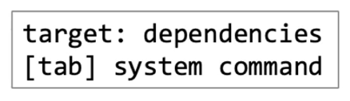

"If you want to create this **target**, we need these **dependencies**. We do this by executing **command**"

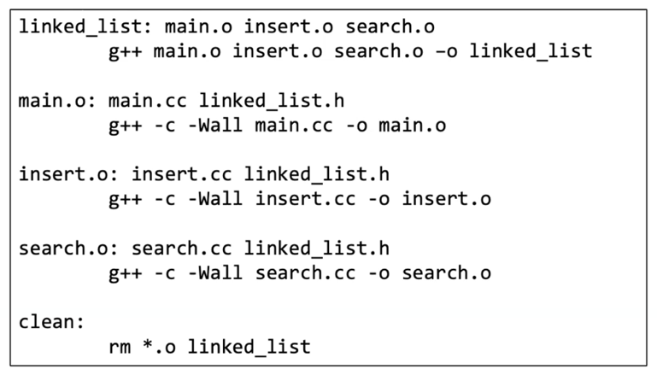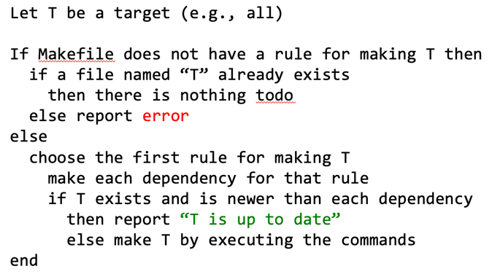

**Command: make target** (= first­_target_by_default)

* First compilation: make can recursively find the commands to get the dependencies needed to get the target in first line
* Next compilations: make will check the timestamps (last modification time) of the dependencies, to see whether the dependencies have newer timestamps than the target (whether they are updated (changed). If so, remake the dependencies

🡪 Automatically recompile the files changed. **We only need to type in "make" even in the next times.**

**Classes and Objects**

1. **Class definition**

To create a class (should be defined in header file)

We can define attributes and methods: (We can always access class attributes inside methods)

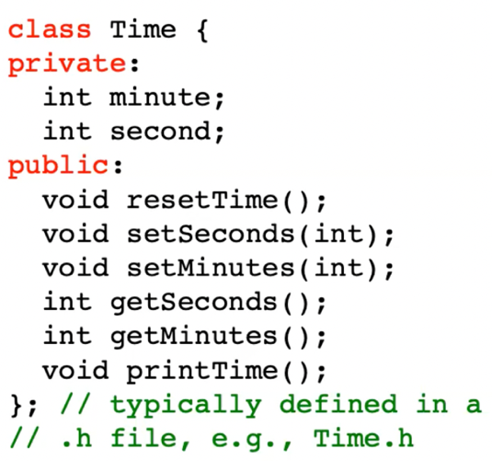

//<-- notice this semicolon!

** Split function declarations from definitions. We declare methods inside the class (in a header file), then define the methods outside the class (in a .cpp file of the same name, #include the header file).

To define a method outside a class, we add Classname:: before method name

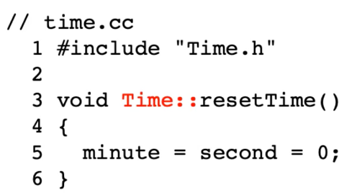

1. **Access Control: Public and Private**

By default, everything in a class is private, meaning class members (attributes and methods) are limited to the scope of the class. If you try to access a private class member, you’ll get an error.

It is a good pratice to use getters and setters (public) and all variables be private.

For getters (and searching functions), we can add a **const** keyword at the end, to catch error whenever the function is modifying the variables. Recall that we can also add const to protect the parameter being passed.

Node* search (int) const;

NOTE that **In C++, access control is per-class, not per-object!**

1. **Instantiating Objects**

To instantiate an object (**on stack**), we can do like how we create a new instance of int, double:

<Classname> <InstanceName> ;

Then we can access/change the attributes and functions of the objects accordingly using “.”

To instantiate object **on the heap**, we can do:

Cat *andrew;

andrew = **new** Cat;

andrew -> resetName(); // equal to (*andrew).resetName();

**new** will return a **address to the object** (that fits with the pointer)

If we do this way, meaning that we have an object declared in the heap

🡪 We will have to delete the object later **delete** andrew

1. **Constructor**

A constructor is a special kind of method that defines how an object of a class is created.

It has the same name as the class and no return type **(not even void)**

**Constructors must be public**

We can have **Multiple Constructors.** A default constructor is not required, even if we have custom constructors.

// time.h

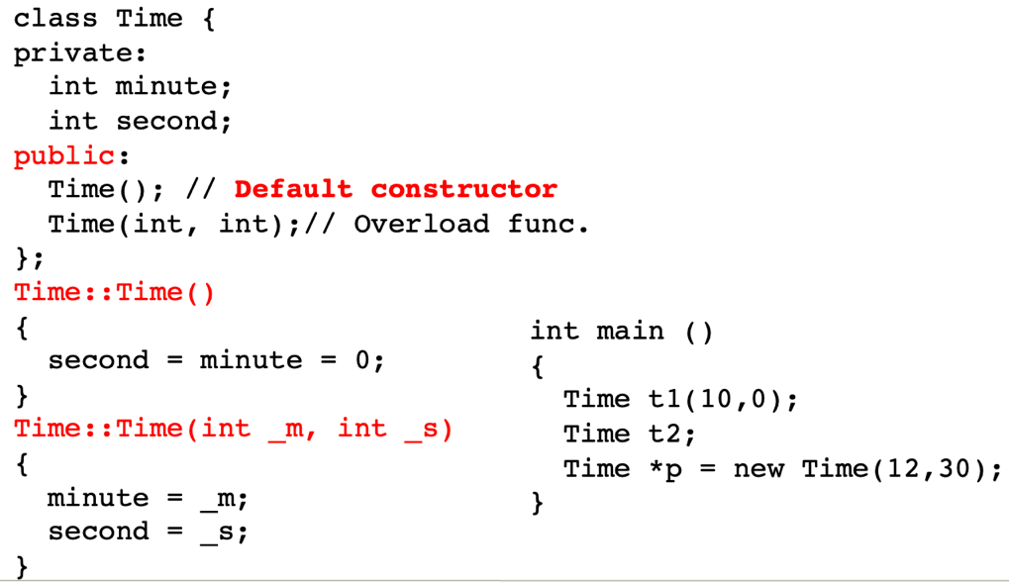

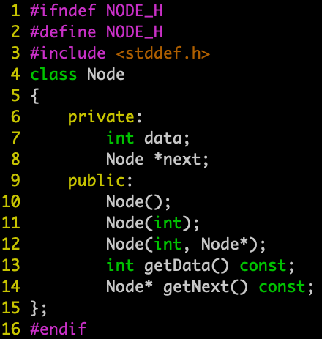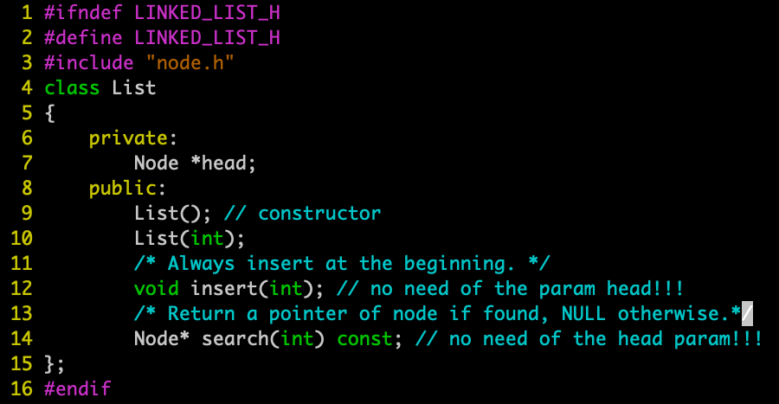**Example: Linked list**

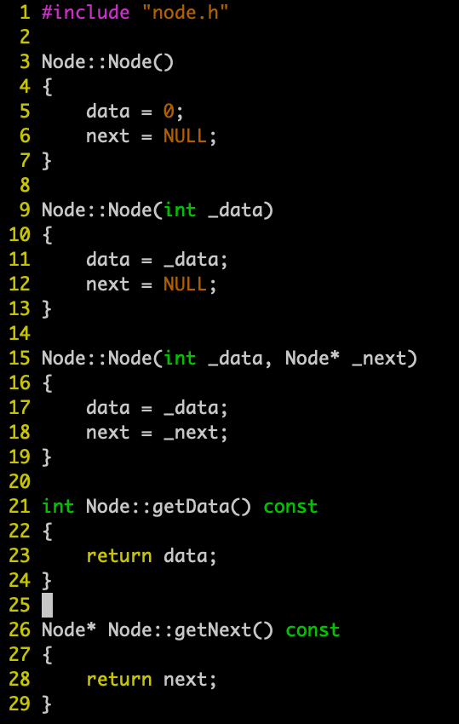

1. **Destructors**

Whenever we call **new**, we should consider **delete** to free the memory on the heap.

* However, NOTE that if we do:

Cat* Tom = new Cat();

delete Tom;

Say that Tom dynamically declares an array on the heap (as a member variable)

delete Tom will free Tom, but the array on the heap isn't! 🡪 Memory Leak!

Therefore, we have to write more code, to free all the values inside.

🡪 Destructors!

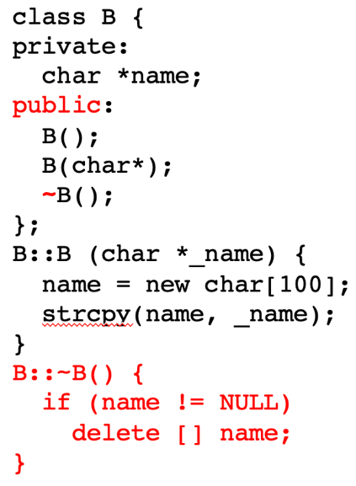

|  |
| --- |
| We generally don’t need to call the destructor; it will be called automatically in any of the scenarios:   * The object moves out of scope. * The object is explicitly deleted. * When the program ends. |

It has the same name as the class and no return type, but is preceded by a ~ operator and takes no parameters.

**\*\*Note that we do delete name only, that will only delete the first element. If we do new[] we must do delete[]**

**Operator Overloading**

Use operators overloading for customized semantics.

1. **Overload operators outside class** (actions are defined by types passed to '+')

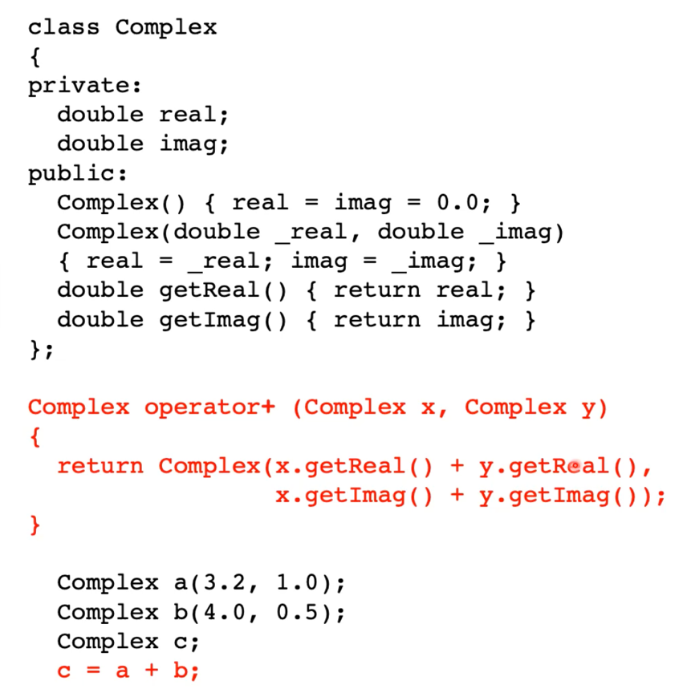

**?** Operator precedence **STILL FOLLOW THE SAME PRECEDENCE**

🡪 Say we have objects a, b, c, d, and we do d = a + b * c 🡪 b * c still happens first!

**? Can we modify the + operator to take only 1 parameter 🡪 NO**

**? How many objects are created??**

* **Depends on the compiler**
  + Min 4
  + Max 7 (calling the "=" operator, the (a+b) argument may be passed by value)
* **When using reference** (Complex &x, Complex &y)
  + Min 4 (creates a Complex when returning)
  + Max 5

1. **Overloading operator as a member function of a class 🡪 Recommended**

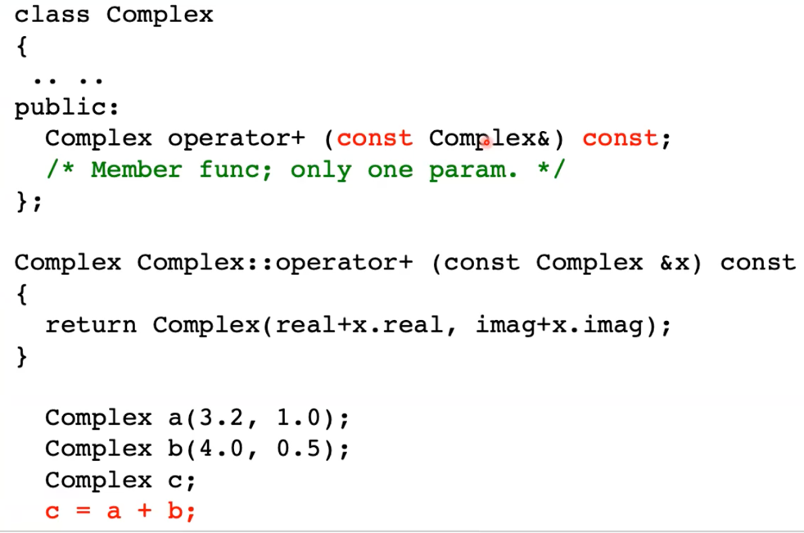

* a + b is the same as a.operator+(b)
* Notice how we can use x.real 🡪 **In C++, access control is per-class, not per-object!**

**\*\*\*\* When passing an object by value to a function, we will have to call**

* **Copy constructor (object to object)**
* **Destructor (when object passed by value got deleted in function scope)**

**Assignment Operator (operator=)**

**The default implementation of "=" operator for objects is doing member-wise copying**

* O1 (type C, stack) and O2 (type C*, heap). O1 = *O2 will call copy assign operator and replace all member variables of O1 by a copy of member variables of *O2. O1 still lives on stack.
* O1 (type C*, points to heap) and O2 (type C*, heap). *O1 = *O2 will call copy assign operator and replace all member variables of *O1 by a copy of member variables of *O2. O1 still lives on stack.
* If O1 (type C*, points to heap), and O2 (type C*, points to heap), doing O1 = O2 will lead to memory leak.
* O1 (type C*, points to stack) and O2 (type C*, heap). O1 = O2 will replace the address stored in O1 with the address stored in O2, and copy assign operator is not called because we are copying a pointer. In this case O1 will point to *O2. The original C that lives on stack will be destroyed based on its scope.

When a copy assign operator is called, it will copy the data from the memory location of source to the memory location of destination. The destination has it members replaced, but it still live at same memory location.

* The Assignment Operator must only be a **member function**

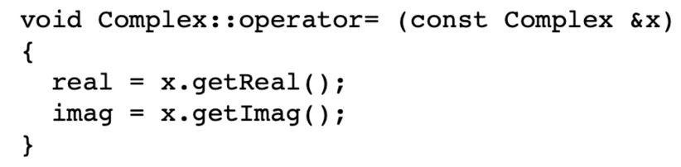

* NOTE: However, this is not sufficient. This supports b = a, but NOT c = b = a, **because there are no return variables**!
* To perform c = b = a, or c.operator(b.operator(a)); we have to return:

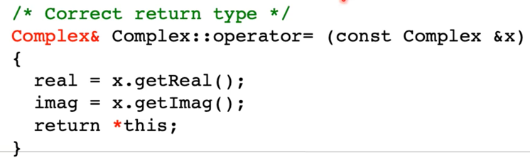

The **this** keyword stands for the address of the object! 🡪 *this will directly return the whole object!

**?** Is the line "return *this" equivalent to "return x"? They are NOT!

For example, b = a, we are returning b by "return *this", and return a by "return x"

**Reference, Pointers, Dynamic Arrays**

1. **Reference**

In C++, a *reference* variable is an alias for something else. No space is allocated - compiler knows the address of the referenced variable 🡪 Just give it another name.

We MUST initialize the reference when declared.

Suppose we already have an **int** variable called **Minh**, we can create an alias to it by using the **&** sign in the declaration:

int &Michael = Minh;

🡪 Calling/Using Michael is now similar to calling Minh.

**We cannot reassign reference**

**Pass-By-Reference**

This means passing parameters to a function by using references 🡪 When called, the function can change the value of the outside variable (if we reassign the argument)

🡪 This will avoid the creation of copies of variable/objects on memory

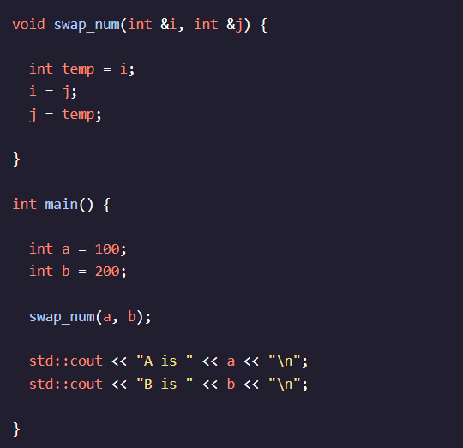

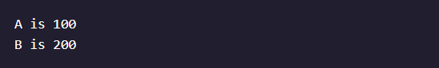

**Pass-By-Reference with Const**

Recall: using the const keyword tells the compiler that we won’t change something (will not reassign)

🡪 **If we pass by reference a const variable to a function (int &i), the compiler will throw error**, regardless of whether the function will actually modify the variable. Therefore, it is required that we include the **const** **keyword** while passing in parameter, assuring compiler that we are not changing.

Therefore, to save computational cost for a function that doesn’t modify the parameter values:

int triple(int const &i) { return i * 3; }

**Memory Address**

The & also means “address of”. Therefore, this operator is used to get the memory address of an object.

Make sure to note that:

* When & is used in a declaration, it is a reference operator.
* When & is not used in a declaration, it is an address operator.

*(declaration === left side of assignment statement)*

1. **Pointers**

The pointer variable stores a memory address.

int* ptr;

ptr = &num;

* When * is used in a declaration, it is creating a pointer.
* When * is not used in a declaration, it is a dereference operator.

**A pointer will always have 4 bytes (32-bit machines) or 8 bytes (64-bit machines) in the memory**. The computer does not know about the type of the value being pointed to; only the compiler does!

**ALWAYS SET TO NULL POINTER AFTER DELETING delete ptr; ptr = NULL;**

1. **Dynamic Arrays**

**int* arr;**

**arr = new int[10];**

**… delete [] a;**

**Memory**

* Memories are stored in cells, each cells having their own addresses in **bytes (8 bits)**.
* Memory addresses are written in hexadecimal numbers (easier for human to read).
* Total space of the memory for a program is **264 bytes** (limit for a program)

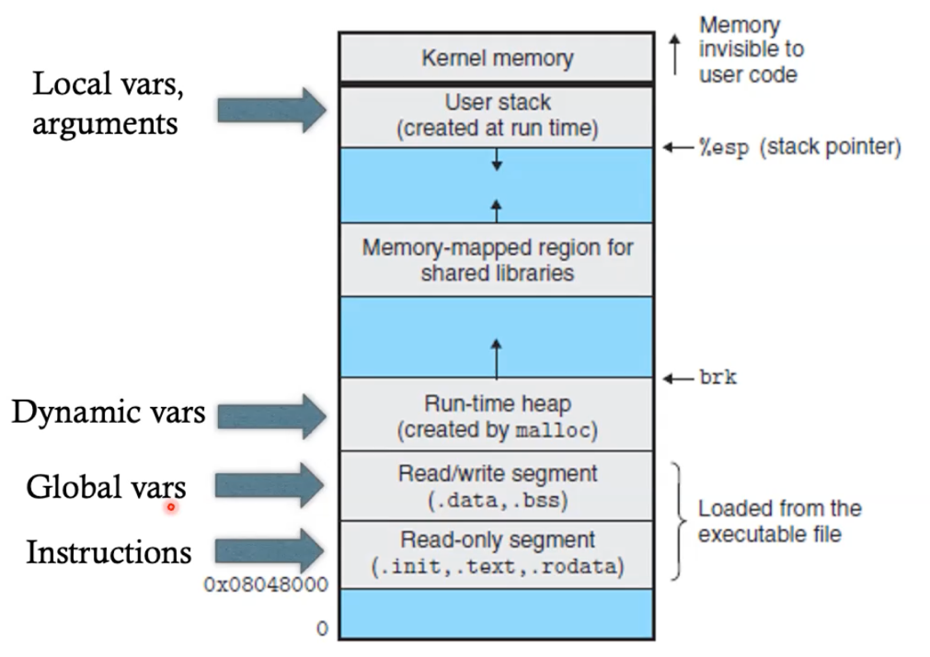

* Instructions are not allowed to be changed, after compilation 🡪 Read-only
* **Sp** - stack pointer - point to the memory region on top of the stack (nothing there)
* Stack will grow downwards (shrink upwards) 🡪 value of sp will be smaller and smaller

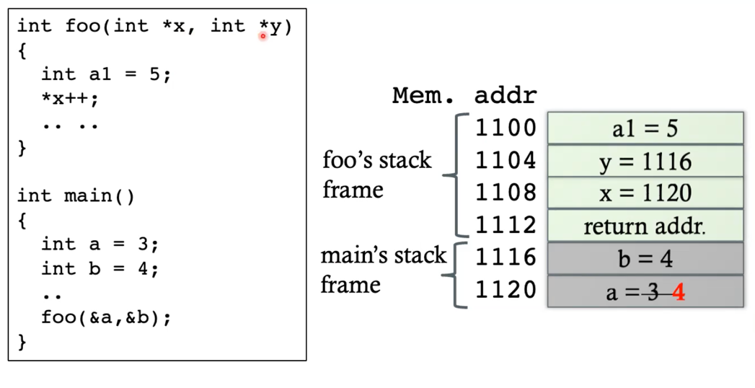

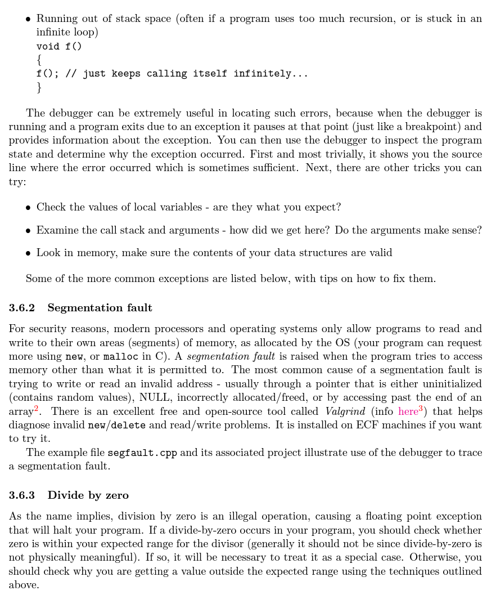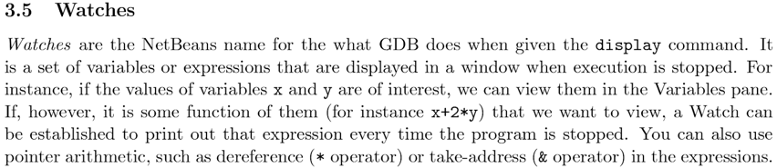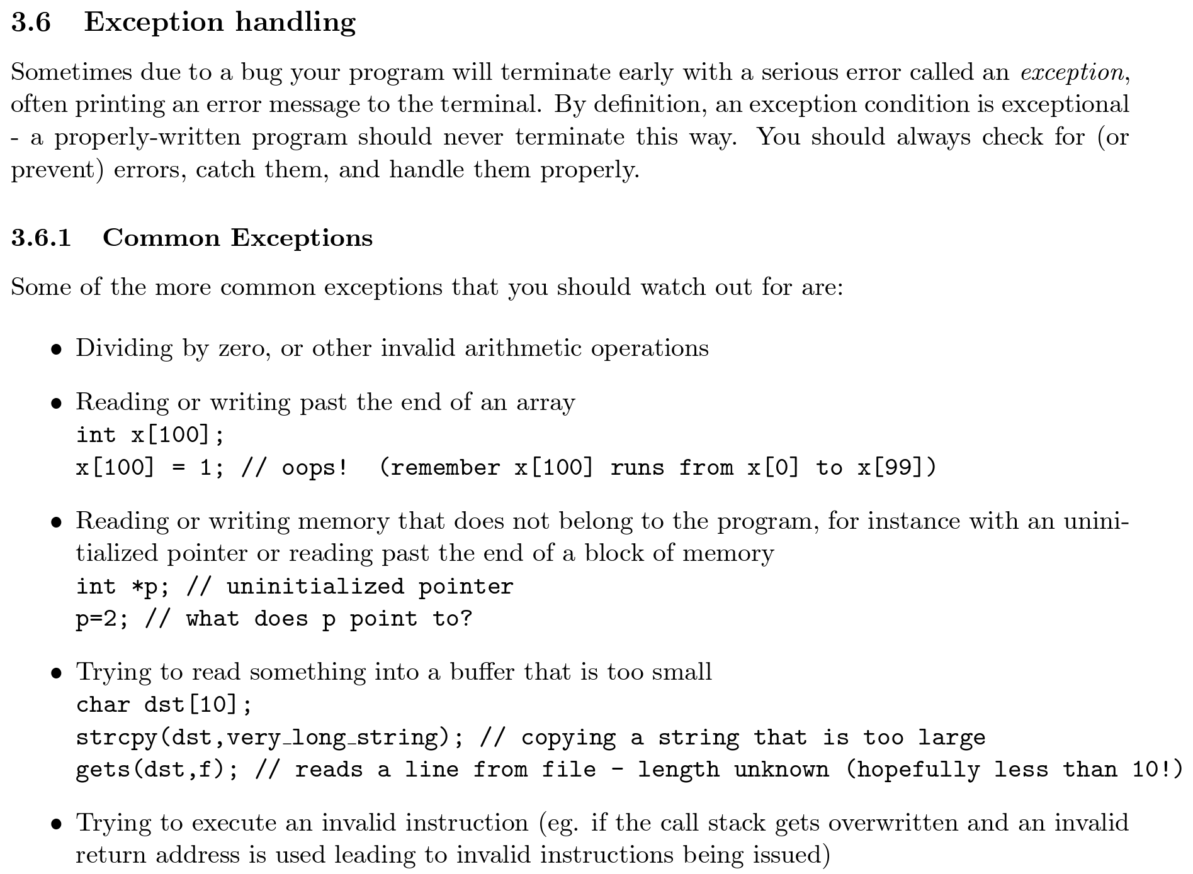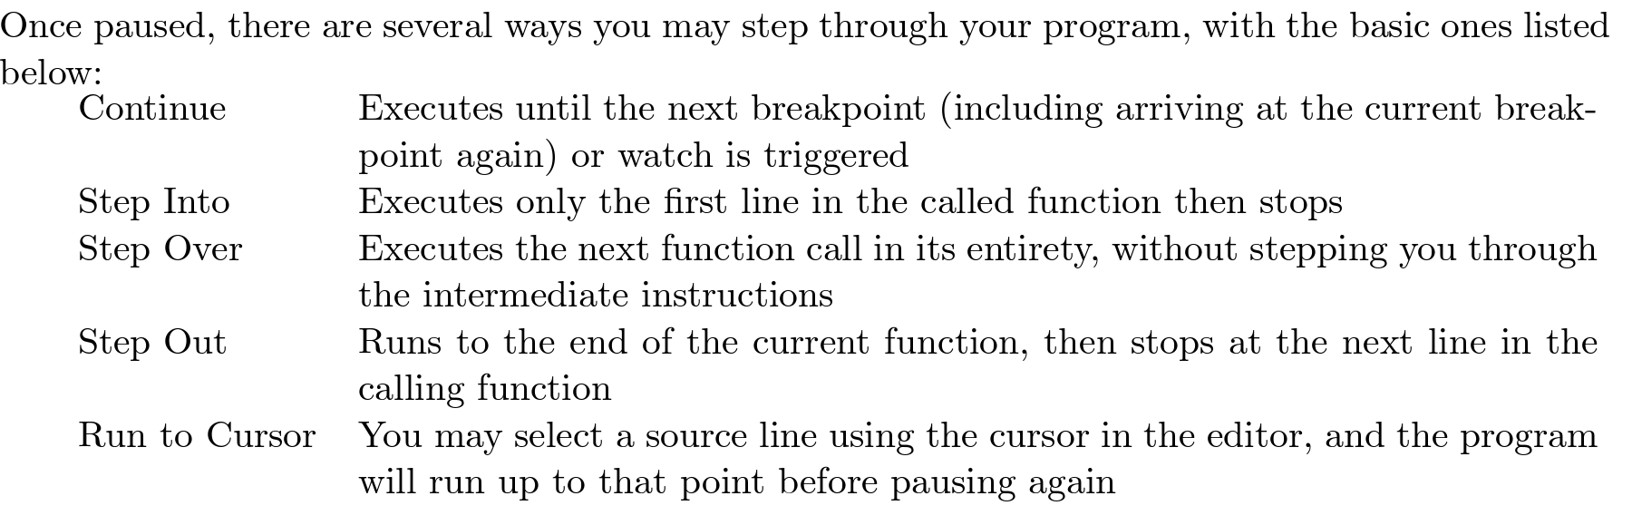

**Copy Constructor**

Say we want to implement the following functions:

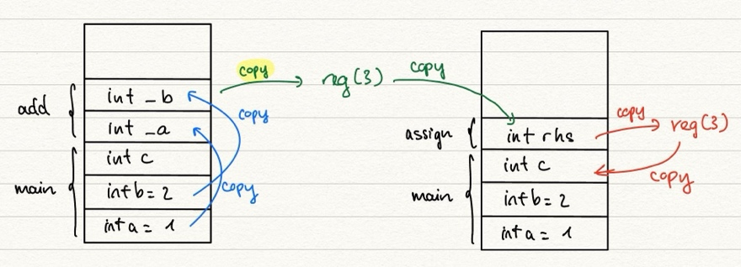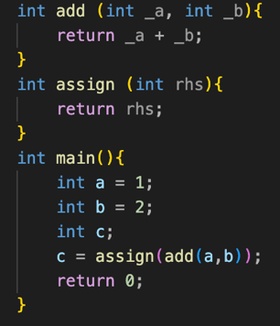Then the following will happen on the stack: (Notice the copy actions)

+) The return value from a function (add or rhs) is **registered** (to somewhere in the CPU)

+) There is copy actions done while passing by value. We also do copy to register.

+) Then, when assigning and passsing values, copy is done.

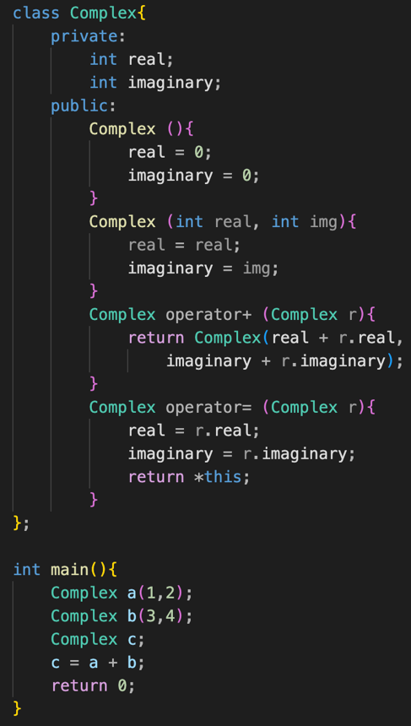**?** So what if copy is done on Objects instead of integers?

When we do c = a + b;

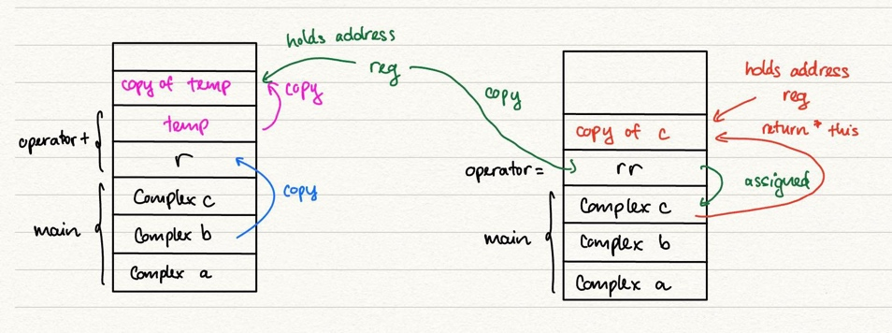**Since it's possible that classes returned exceeds the memory of register, compilers normally make a copy of the return object (maybe on stack), and let register store the address of that object**.**

** If we change operator+ and operator= to pass by reference, the memory for r is no longer needed.

However, if we do c = a + b, we are passing by reference the temporary object returned by '+'. Thus, we MUST declare as const (not changing this temp object) in order to bind it with c.

|  |
| --- |
| **!!! NOTE: We can change the return type of operator= to be Complex&, since we would then avoid creation of "copy of C", and can reference directly to C.**  **However, we CANNOT do the same thing for operator+, since "copy of temp" is a copy of a temporary value that lives on stack, and will get deleted later 🡪 Dangerous** |

1. **Implementation**

So, the following scenarios calls the copy constructor:

+) Pass by value

+) Return by value

+) When instantiating one object from another of the same type

MyClass a(b);

+) **When we declare & initialize an object synchronously**

* !!!! NOT when Complex b; b = a; (this is operator=)

Complex a = b; (since this is considered similar to Complex a(b))

MyClass ( const MyClass& other) { str = new string(other->str); }

**+) Must pass the object by reference! (or else, infinite loop)**

**+) Must use const for the parameter (explained above)**

**+) The default copy constructor is member-wise copy** 🡪 shallow copy!

1. **Use of Const for binding**

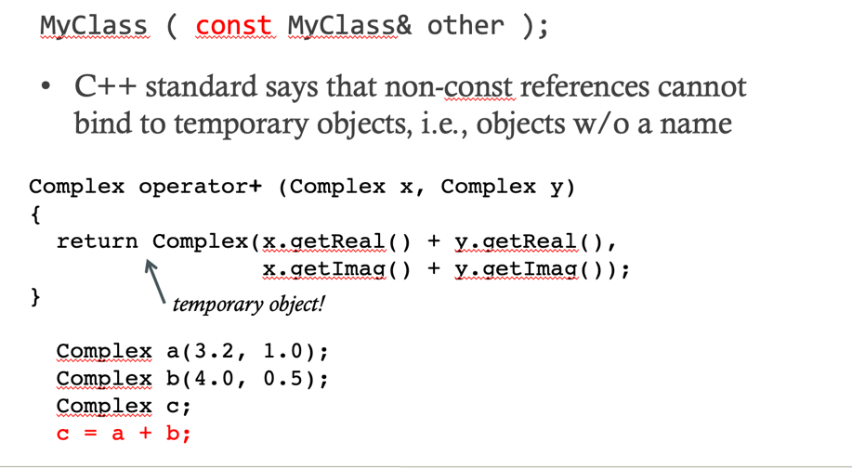

🡪 For operator+, **NO** use const. For operator=, use pass by reference and **use const**

**Linked List**

Now we look into Linked Lists that are sorted.

**?** When do we use Linked Lists, and when do we use arrays?

* Linked Lists are easier to insert/modify and more flexible because of pointers. If we want to insert something in the middle of the array, we have to move all members by 1.
* Also, if we don't know how many members needed, use Linked Lists.
* Arrays are easier to index specific values. If we are not moving the data, the pointers are taking additional spaces, and have more operations (dereference).

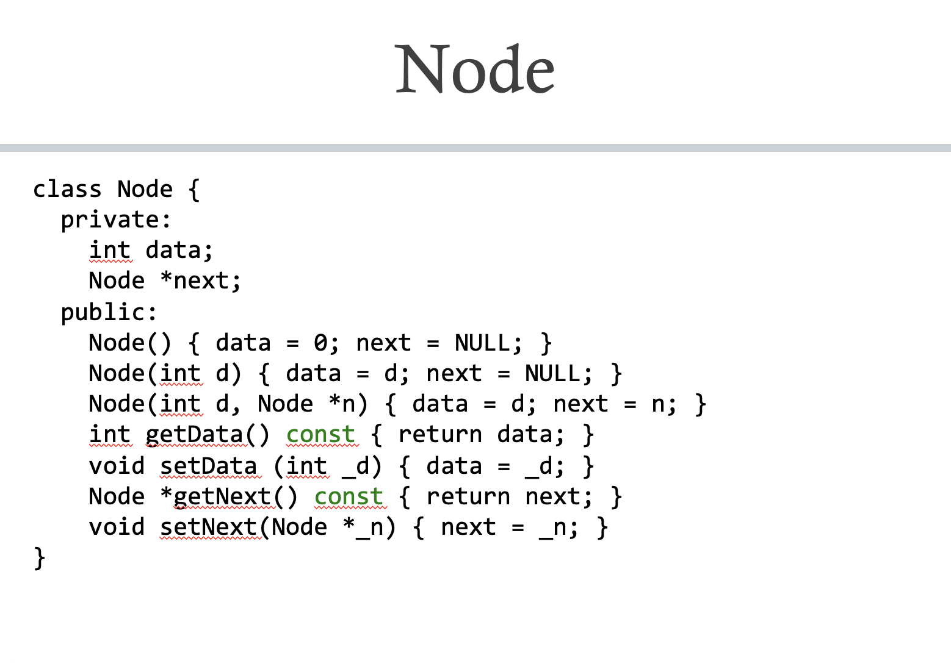

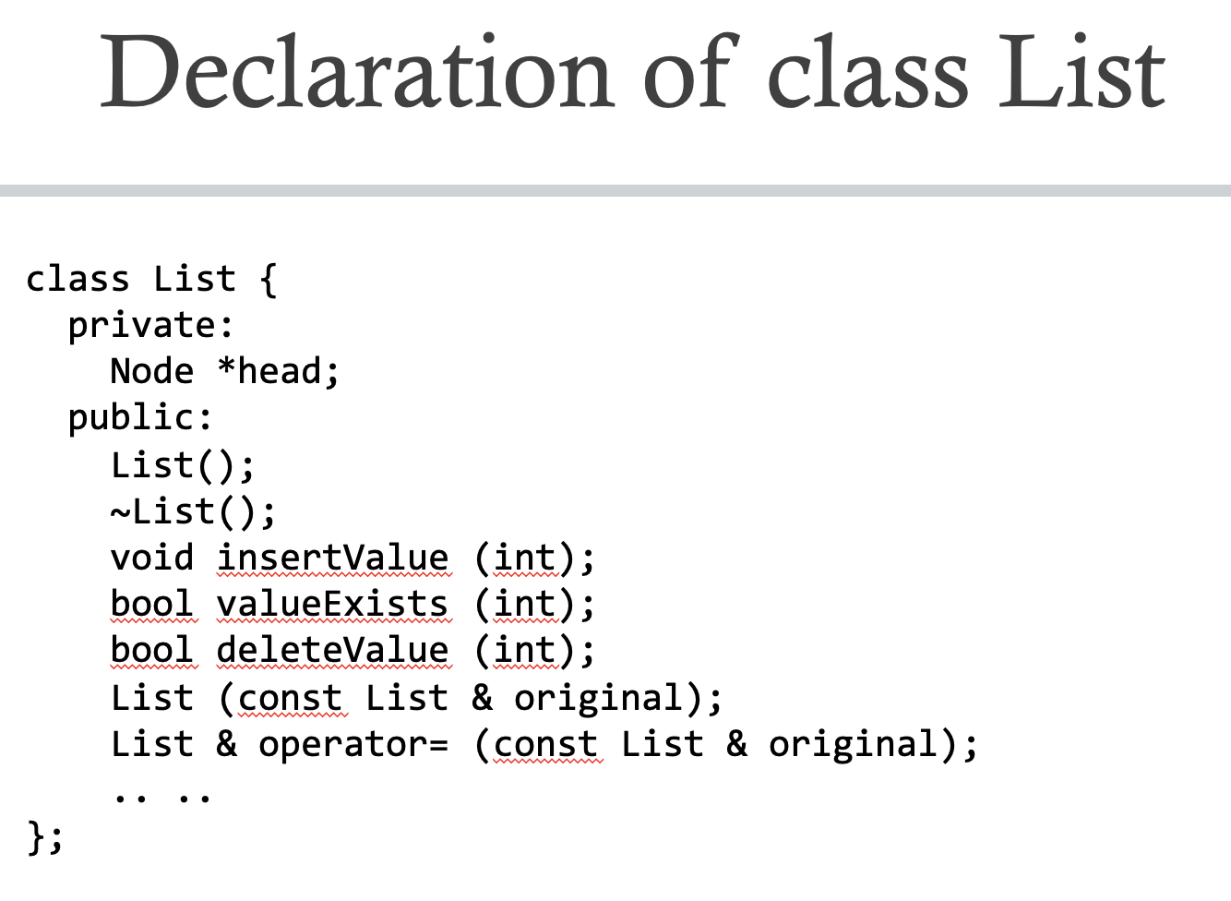

1. **Searching the list**

+) Linked list not sorted

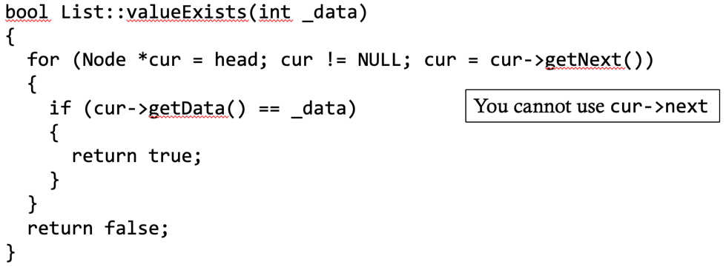

+) Linked list is sorted 🡪 Other conditions for stopping

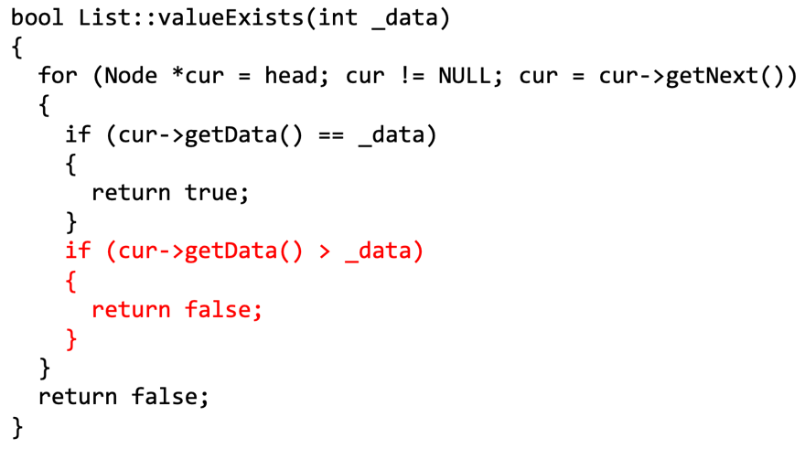

1. **Insert into List**

Special cases to consider:

* Inserting at head
* Inserting at end
* Inserting at middle

**We need to keep track of also **the previous node** (unless we do node->getNext()->getData())

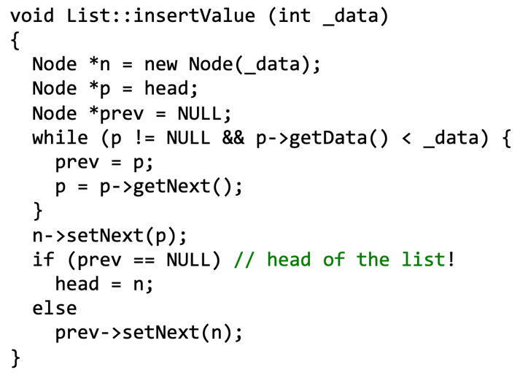

1. **Delete a Node**

Also needs 2 pointers (to have access to the previous node)

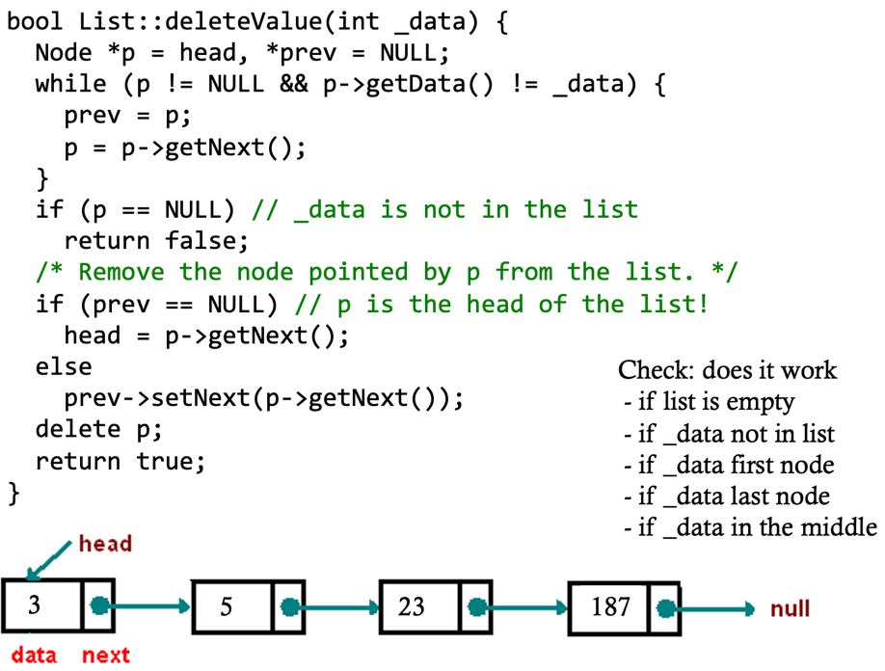

1. **Destructor**

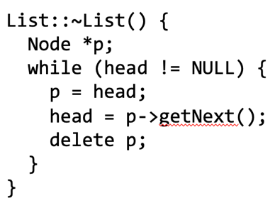Since now that every node is dynamically allocated, we **need destructor** to avoid memory leak.

// Here we are changing head from beginning to end, and p is the previous head (that gets deleted)

1. **Copy Constructor**

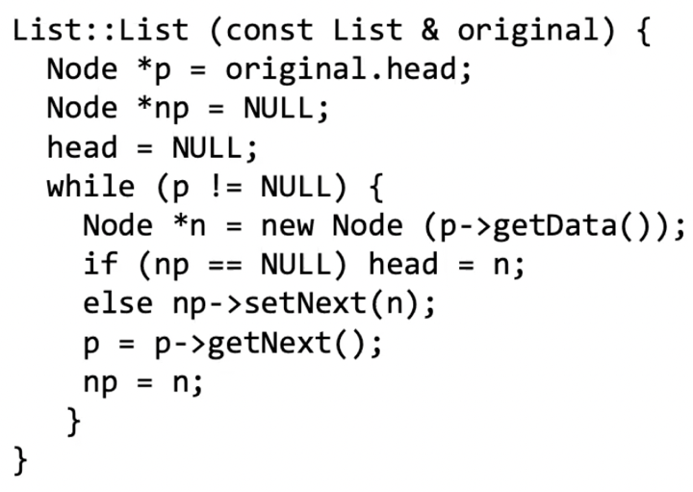It's obvious that we need to make a **deep copy** for the linked list, not shalow copy.

**NOTE that "head" in line 4 is the "head" of the new LinkedList (that we call copy on)**

**🡪 DO NOT create a new head !!!**

1. **Assignment Operator**

lhs = rhs

This is similar to copy constructor, but we must deal with **edge cases**

* lhs is not empty 🡪 Avoid memory leak
* rhs is the same as lhs 🡪 Don't need to copy at all.

// Note that we are not comparing "same contents", we are comparing "same objects"

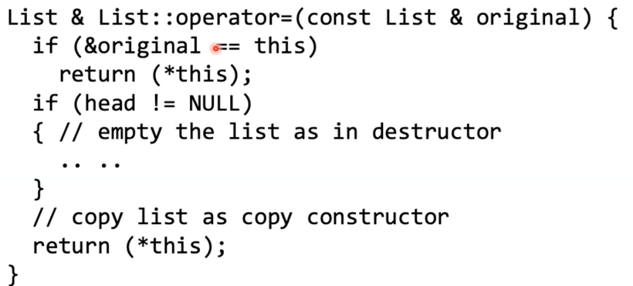

**Recursions**

"Breaks down problem to be solved into smaller, discrete steps that are solved using **same** algorithm" 🡪 **MUST SET STOPPING CONDITION**

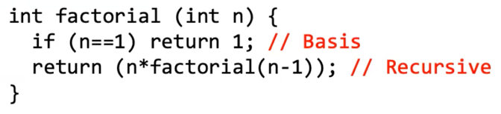**Factorial**

**Linked List**

* 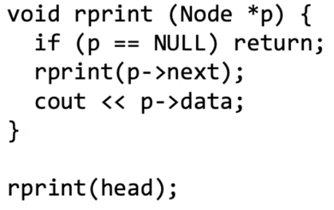In this version, we are printing from end -> beginning
* If we switch orders of rprint and cout, we are printing in forward order

**Quick Sort** - best = average **=** O(n*log(n)), worst = O(n2)

One of the **most efficient** sorting algorithms.

qsort in stdlib.h

Idea

* Pick a pivot value from an array
* Move every value < pivot to the left of the pivot
* Move every value >= pivot to the right of the pivot
* Quicksort sub-array to the left of pivot
* Quicksort sub-array to the right of pivot

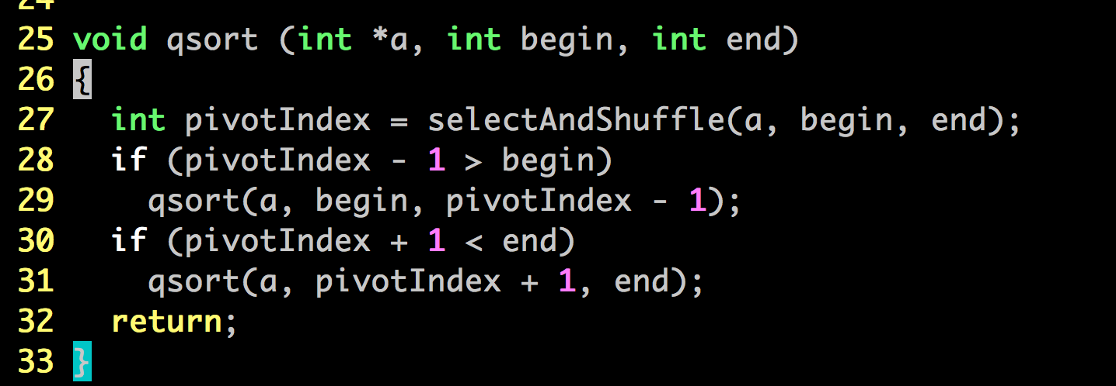// pivotIndex - 1 <= begin or pivotIndex - 1 >= end happens when the pivot is at the positions that we DON'T NEED to do recursion anymore

(0 element or 1 element in sub-array)

// Select and Suffle will select the pivot, move stuffs to left & right of it (meaning, moving the pivot to the "middle", then return new pivot index

** **selectAndSuffle**

Idea

[begin, begin + 1, begin + 2, … , end]

* Iterate through array, **swap** current-th element < pivot to a[i]
  + i starts from begin + 1 and loops til end
  + starts from begin + 1 because a[begin] is the pivot itself. Pivot stays at a[begin] til last step.
  + Current is an index and starts at begin. It keeps track of the index where **smaller element should be placed to**.
  + Whenever we meet element < pivot, current moves up, and swaps a[i] to that index.
  + Current will **always** end at the index where pivot should be (if there are k elements smaller than pivot, the pivot will be placed to k-th index)
  + Therefore, after the loop, swap a[current] with a[begin] where the pivot is.

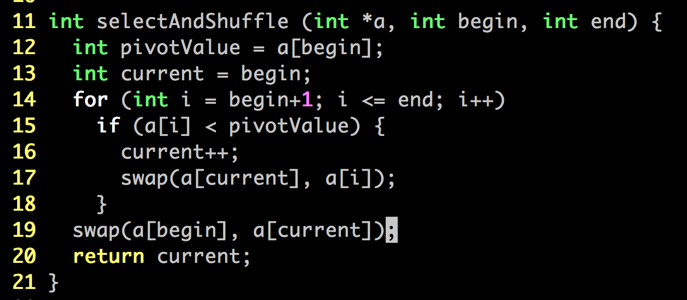

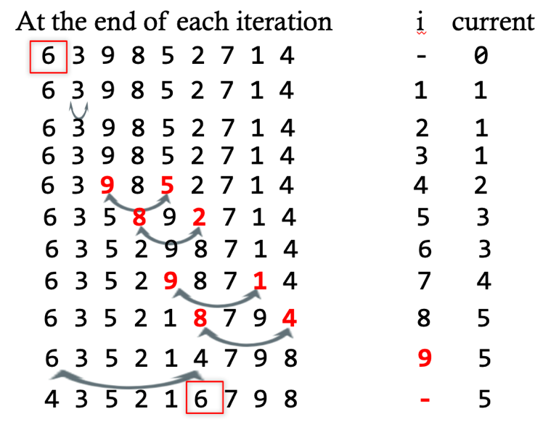

**Complexity**

* Best case: Assume that we are always picking the pivot by median value, there would be log2(n) tree levels 🡪 Average performance, for each level of tree (scanning all n elements) O ( n*log(n) )
* Worst case: Always choose smallest/largest pivot 🡪 Every time we only reduce the number of elements in the array by 1 🡪 n levels of tree 🡪 Complexity O(n2)

Therefore, it's not a good practice to actually just pick the first value for pivot.

In reality, we usually compare first, last, and middle number to pick (good approximation)

median ( a[begin], a[middle], a[end] )

**Insertion Sort** - best O(n), average = worst = O(n2)

**void** insertionSort(**int** arr[], **int** n)

{

**int** i, key, j;

**for** (i = 1; i < n; i++)

    {

        key = arr[i];

        j = i - 1;

        // Move elements of arr[0..i-1], that are greater than key,

        // to one position ahead of their current position

**while** (j >= 0 && arr[j] > key)

        {

            arr[j + 1] = arr[j];

            j = j - 1;

        }

// "Insert" key to its position

        arr[j + 1] = key;

    }

}

------------------------------------------------------------------------

**void** insertionSortRecursive(**int** arr[], **int** n)

{

    // Base case

**if** (n <= 1)

**return**;

    // Sort first n-1 elements

    insertionSortRecursive( arr, n-1 );

    // Insert last element at its correct position in sorted array.

**int** last = arr[n-1];

**int** j = n-2;

    /* Move elements of arr[0..i-1], that are greater than key, to one position ahead of their current position */

**while** (j >= 0 && arr[j] > last)

    {

        arr[j+1] = arr[j];

        j--;

    }

    arr[j+1] = last;

}

**Selection Sort** - always O(n2)

**void** selectionSort(**int** arr[], **int** n){

**int** i, j, min_idx;

    // One by one move boundary of unsorted subarray

**for** (i = 0; i < n-1; i++){

        // Find the minimum element in unsorted array

        min_idx = i;

**for** (j = i+1; j < n; j++)

**if** (arr[j] < arr[min_idx])

            min_idx = j;

        // Swap the found minimum element with the first element

**if**(min_idx!=i)

            swap(&arr[min_idx], &arr[i]);

    }

}

------------------------------------------------------------------------

// Return minimum index

**int** minIndex(**int** a[], **int** i, **int** j){

**if** (i == j)

**return** i;

    // Find minimum of remaining elements

**int** k = minIndex(a, i + 1, j);

    // Return minimum of current and remaining.

**return** (a[i] < a[k])? i : k;

}

**void** recurSelectionSort(**int** a[], **int** n, **int** index = 0){

    // Return when starting and size are same

**if** (index == n) **return**;

    // calling minimum index function for minimum index

**int** k = minIndex(a, index, n-1);

    // Swapping when index and minimum index are not same

**if** (k != index)

       swap(a[k], a[index]);

    recurSelectionSort(a, n, index + 1); }

**Bubble Sort** - best O(n), average = worst = O(n2)

**void** bubbleSort(**int** arr[], **int** n)

{

**int** i, j;

**for** (i = 0; i < n - 1; i++)

        // Last i elements are already

        // in place

**for** (j = 0; j < n - i - 1; j++)

**if** (arr[j] > arr[j + 1])

                swap(arr[j], arr[j + 1]);

}

------------------------------------------------------------------------

// A function to implement bubble sort

**void** bubbleSort(**int** arr[], **int** n)

{

    // Base case

**if** (n == 1)

**return**;

**int** count = 0;

    // One pass of bubble sort. After this pass, the largest element

    // is moved (or bubbled) to end.

**for** (**int** i=0; i<n-1; i++)

**if** (arr[i] > arr[i+1]){

            swap(arr[i], arr[i+1]);

            count++;x`

        }

      // Check if any recursion happens or not

      // If any recursion is not happen then return

**if** (count==0)

**return**;

    // Largest element is fixed, recur for remaining array

    bubbleSort(arr, n-1);

}

**Binary search Tree**

* No cycle (Function calls in C++ are also tree structure, with the root as the main() function)

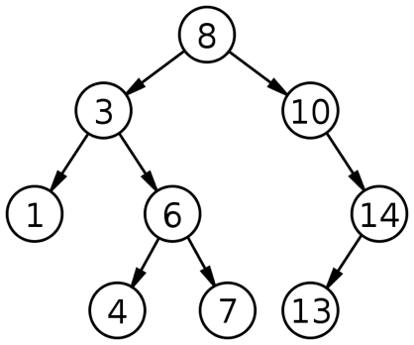**Binary Search Tree**

* Each tree has at most 2 children
* Nodes in left subtree have values <= value of node
* Nodes in right subtree have values > value of node
* Min value: left most child
* Max value: right most child

Why this data structure?

* Compare with binary search for a sorted array? (array sorted, pick middle value…)
* For arrays, it's still the same problem: hard to insert values (have to move all values)

**Traversing orders**

1. **Pre-order**: node, left subtree, right subtree (act on the node before visit left, then right)

8, 3, 1, 6, 4, 7, 10, 14, 13

1. **Post-order**: left subtree, right subtree, node

1, 4, 7, 6, 3, 13, 14, 10, 8

1. **In-order**: left subtree, node, right subtree

1, 3, 4, 6, 7, 8, 10, 13, 14

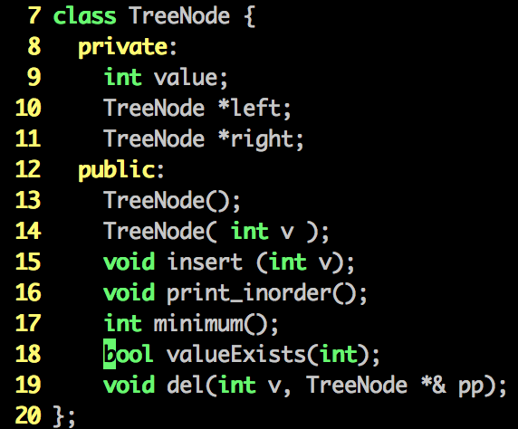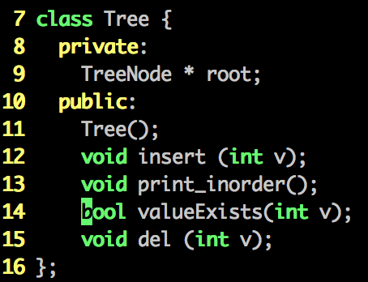**Class declarations**

Note that TreeNode also has insert, print_inorder, etc. (because we are treating each node as a root 🡪 **All the implementations are recursive**!

**Tree Class**

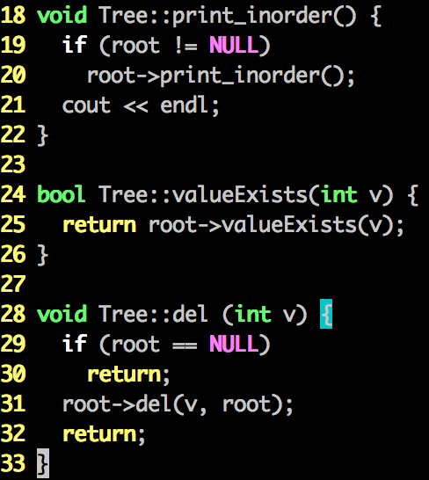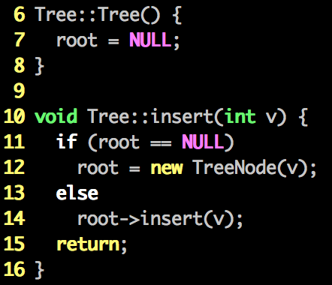

// for valueExists: add **if (root == NULL)**

// del passes treeNode pointer by reference

**TreeNode Class**

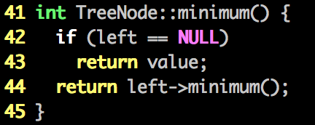**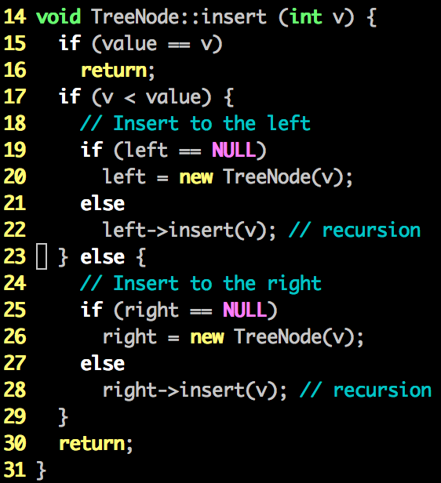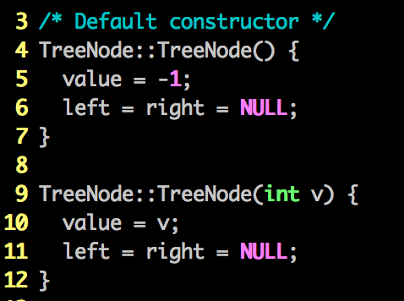 Constructors**  **Insert Minimum value**

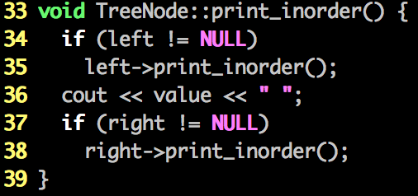 **In-order traversal**

**Destructors**

Must traverse **post-order** (must delete left and right before deleting itself)

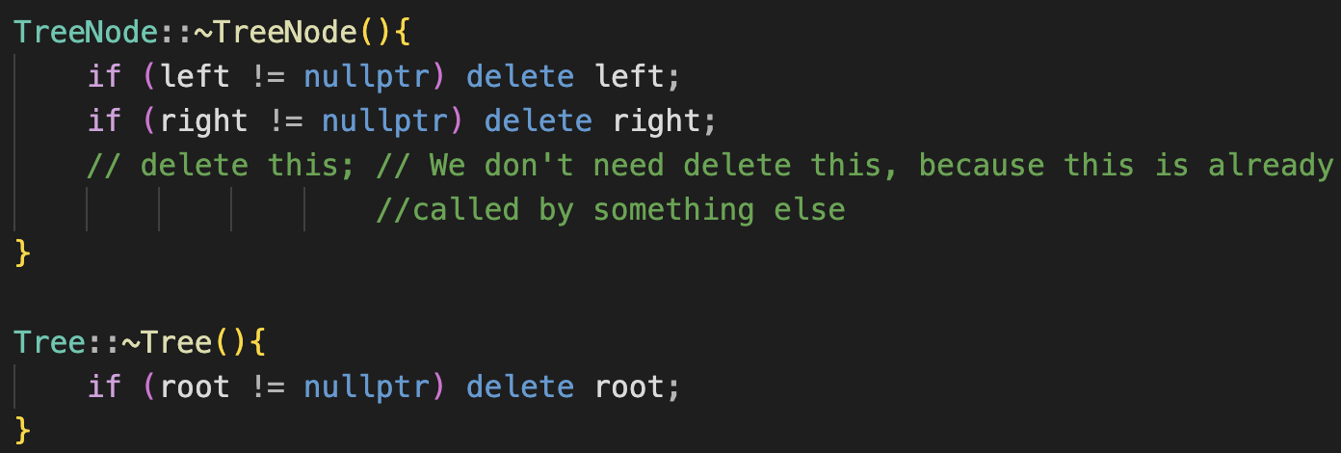

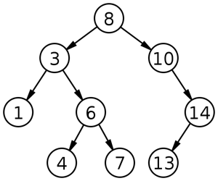**TreeNode::del (int v, TreeNode *& pp)**

* If node (1) has no children, simply delete & set to NULL
* If the node (10) has only right child (14), we can directly set the child (14) to right of parent (8)
* If the node (14) has only left child (13), we also do the same, set child (13) to the left of parent (10)
* If the node has both right and left child (6), (3), (8)
  + Replace the node with the smallest value of the right subtree (A), or with the largest value of the left subtree (B)
  + 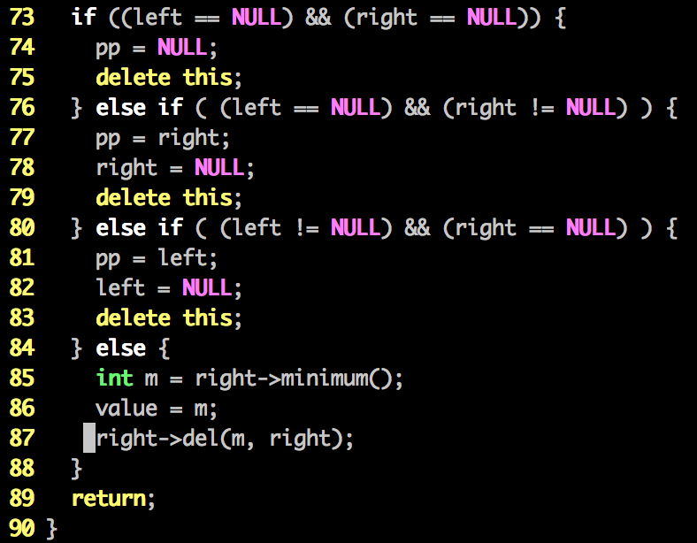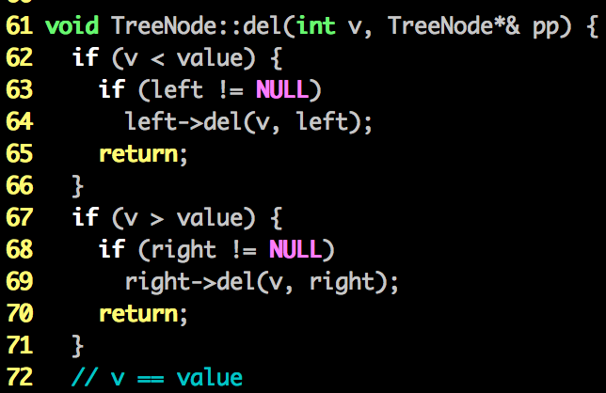When this happens, there will be 2 instances of A or B in the tree 🡪 do a recursive call again for A or B, but this time the case is already covered above (A will not have left child, B will not have right child)

// Find the node to be deleted

// The 4th case is "soft" delete, where we only changed the value on the current node.

|  |
| --- |
| // Pass pointer1 only would create pointer2 that points to the same object. Although we can modify object, we cannot modify what pointer1 points to |

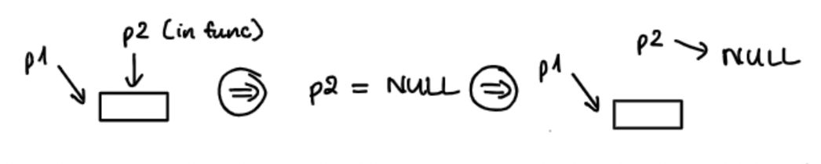

*p1 still points to the object!*

**Inheritance**

The **child class** inherits properties of the **parent class** (all member variables and functions)

* Must #include "SuperClass.h"

Syntax:

class DerivedClass **: public** BaseClass {

/* Only list inherited members if we wish to change them,

add the new members we're adding */

// assume for now public is a keyword

};

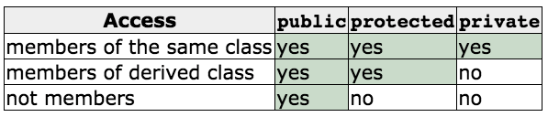

Note that if we declare a **function** as **protected**, then instantiate a children object. We still cannot call that function in main() (protected grants access to derived class definition only)

The children inherits the members, but cannot access private ones.

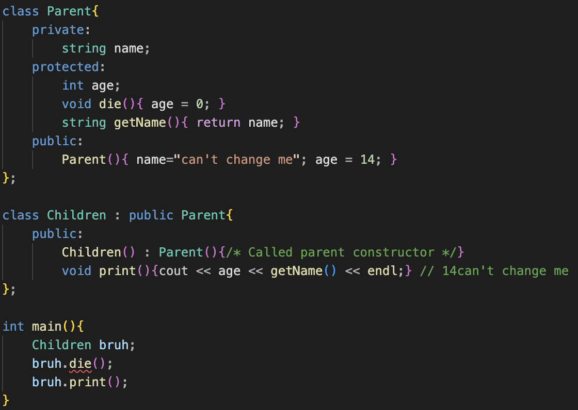

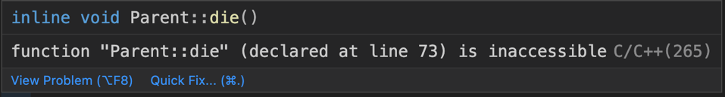

**Overriding vs Overloading**

* Overloading: same function name, different parameter list
  + void foo (int v);
  + void foo (double d);
  + void foo (int i, int j);
* Overriding: redefine a function in derived class (not deleting the Parent's ones)
  + List::insert (int a);
  + OrderedList::insert (int a);

Note that the List::insert (int a) is still there (just that the scope is different) 🡪

* You can also redefine a member var, say “a”, w/ the same name in derived class
  + There will be two copies of “a” – one in base obj. and one in derived class obj.

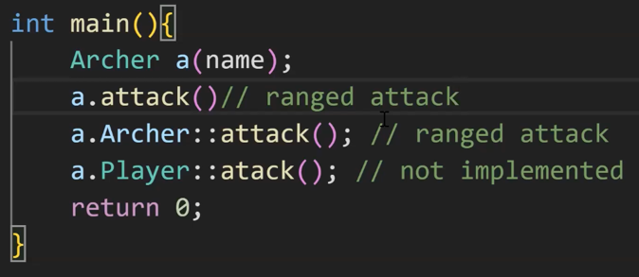

**Mixing Types (motivation for polymorphism)**

We can treat the child object as the parent object (ignoring all its additional values), but you cannot treat the parent object as a child

🡪 We can always go up (more general) but never go down (more specific)

🡪 This is intuitive, because we child object has more than the parent object

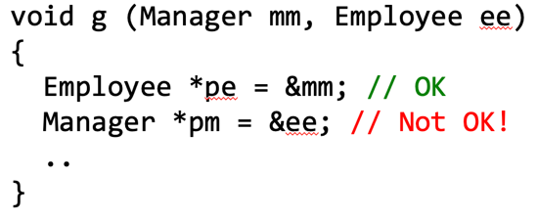

Usage: We can mix different types of child into a similar data structure, by treating them similarly by their parents

Player array[5]; // We can fit in here every children of Parent

|  |  |  |  |  |
| --- | --- | --- | --- | --- |
| Warrior | Archer | Wizard | Warrior | Sniper |

**However,** this has some limitations. Say that we overrode the attack() function in every child classes (Warrior do melee, Archer do ranged, etc.). Then if we want every Players in the array to attack by doing:

for (int i = 0; i < 5; i++){

array[i].attack(); // This is because we defined the array of Player

}

This will call the unimplemented attack() version of the parent Player class! **LIMITATION!**

Therefore, there developed an idea of **polymorphism!**

* Note that if we do Player* base_class_ptr still has no idea about the newly defined member variables and methods of the derived class.
* Player* base_class_ptr will simply treat the derived class as the base class.

**Notable questions (pointers)**

Base a;

Derived b;

a = b; **// This will call Base operator= (Base &rhs) 🡪 b can fit into rhs**

b = a; **// This will call Derived operator= (Derived &rhs) 🡪 a can't fit into rhs**

Base* baseptr; // pointing to some Base

Derived* derivedptr; // pointing to some Derived

baseptr = derivedptr; // Base pointer can point to Derived object

derivedptr = baseptr; // Derived pointer **cannot** point to a Base object

It is possible to do:

Base *a = new Derived ( ); // Still creates a Derived object, but through a, it is

// treated as a Base object.

**Polymorphism**

Recall that if we call an object by its parents, the overrode functions (within children's class) will not be called (since the compiler is considering the object as the derived class)

**AND,** we can't even do the new functions that we defined for the children class!

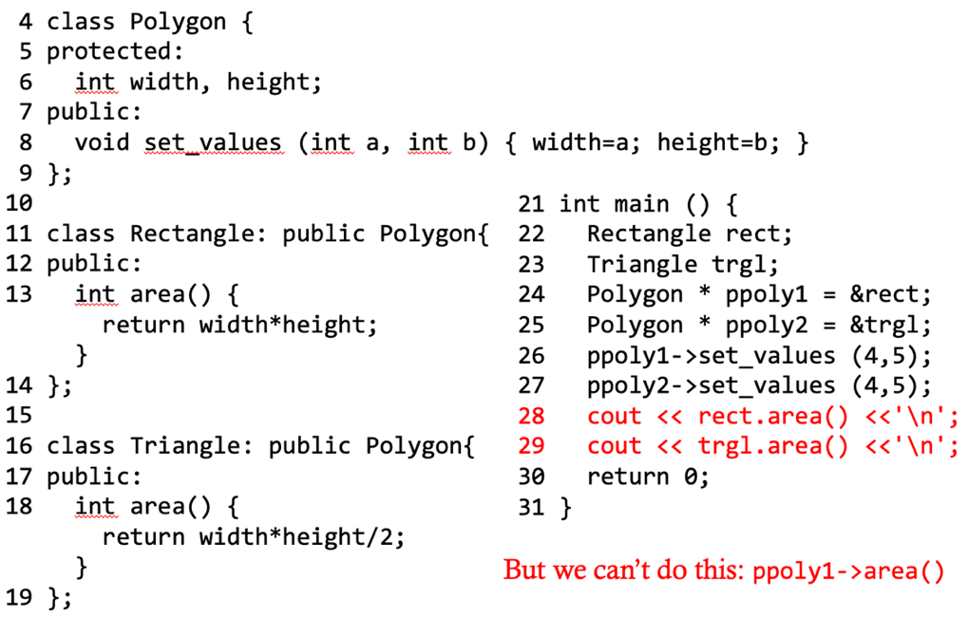🡪 Compile error !!!!

In general, we want to use a pointer to the base class object to invoke a function that is implemented in a derived class

Note that if we call a function in base class that invokes a virtual function, we will still call the one implemented in derived class

**SOLUTION: virtual functions**

**If a function is declared as virtual in base class A, and redefined in derived class B, then**

**B derived_obj;**

**A* ptr = &derived_obj;**

**A -> redefined_func()** // will call redefined_func() in derived class B

** A class the declares or inherits a virtual function is called a polymorphic class

* The decision to which redefined function to call is made at runtime 🡪 late binding
* Virtual function in base class is like a "dummy" function declaration
  + Since only the children will define the behavior of this function, we can use a syntax to **declare that base class does not know what function do**

**virtual int area() = 0;** 🡪 The base class will be abstract class

🡪 This is called purely virtual function

**🡪 We cannot instantiate an object of abstract class (but can still create a pointer to abstract class, pointing to derived class objects)**

**🡪 We must override the function in Derived class. Else, the Derived class is also abstract 🡪 cannot instantiate an object of Derived class also!**

* You **cannot** declare a member variable as virtual. Only functions!

**Vtable**

**? So how does the compiler "know" which function from which derived class to call?**

* The moment you declare a function member of a class as "virtual", the compiler will create a vtable (virtual method table) as a hidden member variable of that class, and any object that inherits from it
* There is a separate vtable for each class both based and derived (not for each object)
* The vtable only contains virtual functions that maps to the function target

Say we have these classes:

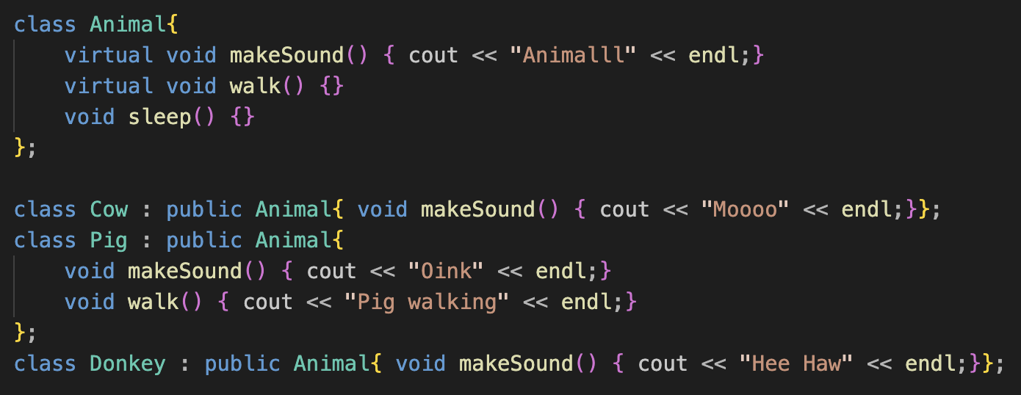

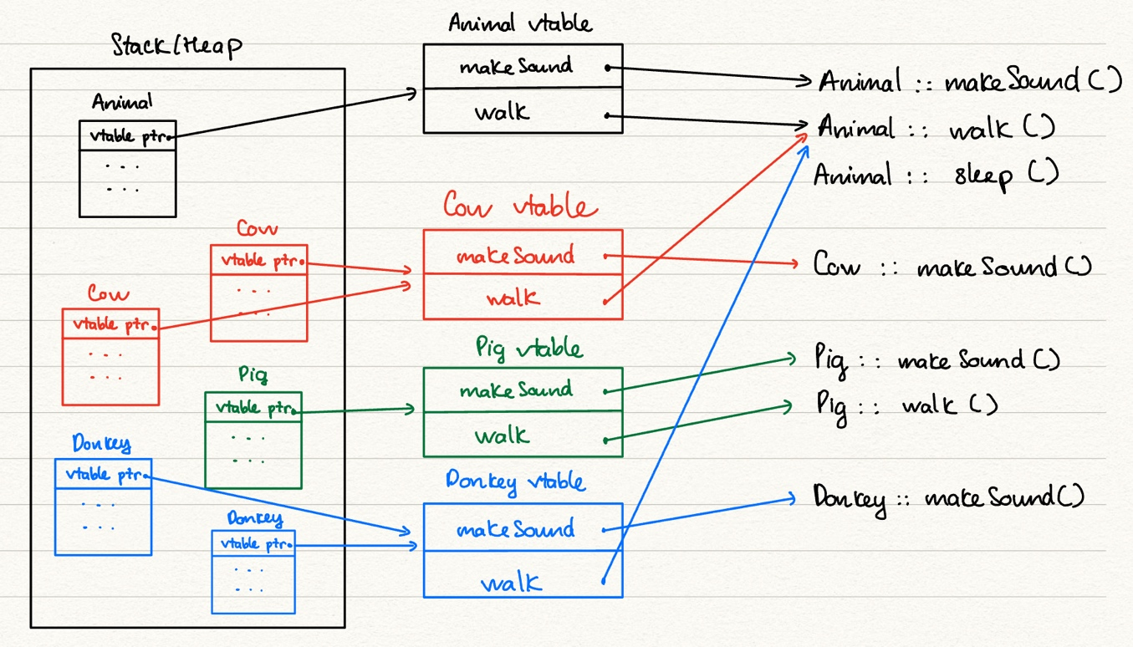

As we can see, there are additional space and process that has to be done 🡪 slows down 6-13%

Remember that these calls only happen if we are doing polymorphism on derived objects.

**Constructors**

An object of Derived class does not have Constructos, Destructors, Copy & operator=

**If these functions are not defined in Derived (or does not call the correct corresponding Base function), the default behavior would be to call the parent's corresponding version 🡪 ERROR**

|  |
| --- |
| * **Constructor |** *Derived::Derived(int n)* will call *Base::Base()* before itself by default * **Destructor |** For destructors, *Base::~Base()* is automatically called after *Derived::~Derived()* --> we don't need to explicitly call ~Base() * **Copy Constructor |** For *Derived::Derived (const Derived & original) { }* , the default behavior will call *Base::Base()*--> ERROR * **operator= |** *Derived::operator=(const Derived & rhs)* (no default behavior) |

1. **Constructors**

The child constructor will **always** **call a parent constructor before itself**

* If you don't explicitly call any base constructor, the default base constructor is called when initializing a derived class object.
* If we simply define a child constructor, it will call default parent constructor before itself (there will be an error if there's no default parent constructor while there is a non-default parent constructor)(compiler will create a default constructor if NO constructor is defined for parent)

Warrior (string &n) { // this will call default parent constructor

//…something

}

* Non-default constructors are "NOT" inherited. Say Base::Base(int n) is defined, then Derived::Derived(int n) will be an error.
  + Before child's constructor, we can call a non-default constructor of a parent's class (parameters passed by derived class constructor)

Warrior (string &n) : **Player(n)** { // … additional children constructor }

|  |
| --- |
| *** Note that in the example, calling the parent constructor Parent() will "start" the name and age of the Parent, for which the Children can access the age (14), but still not the name.  The access control holds (Children can access protected and public only) |

**Syntax:** Instead of initializing member variables in brackets, we can do with the syntax

🡪 Allows passing in the parameters to the constructors of based class

Employee::Employee(string n, int s) : name (n), sin(s) { /* deliberately left empty */ }

Manager::Manager(string n, int sin, int _level) : Employee(n, sin), level(_level) { /*empty*/ }

**Destructors**

The child destructor will **always call a parent destructor after itself - automatically called**

Like constructors, we can also override the child's decstructor as well.

The order of destructor invocation: ~Son() -> ~Dad() -> ~Grandpa()

**Copy Constructor**

Deep copy base class member variables:

1. Call **base class** copy function (This will not be done if we do shallow copy!)
2. Deep copy extra member vars contained in derived class

Base::Base (const Base & original) {

// Deep copy **original** into **\*this**

}

Derived::Derived (const Derived & original) **: Base(original)** {

// Deep copy extra Derived vars

}

*** You have to call Base(original) yourself. If not, the **Base::Base()** will be invoked (**serious logical error)**

**Operator=**

Base & Base::operator= (const Base & rhs) {

// Deep copy

}

Derived & Derived::operator= (const Derived & rhs)

{

**Base::operator=(rhs);**

// Deep copy any extra Derived variables

return (*this);

}

***Note that by default, operator= does not call Base::operator=. However, you don't have to call Base::operator= to avoid compile error (but it might be a logical error)

** If operator= or copy constructor in Derived class is not defined, then the default behavior is the operator=/copy of the Base (or the default of Base generated by compiler, if not defined)

**Complexity**

* T(n) means the time it takes to run a task
* Benchmark: a = b 🡪 T(n) = 1

sum = 0;

for (int = 0; i < n; i++) 🡪 T(n) = 2 + 3*n 🡪 O(n)

sum += i;

* Linear Search (3 cases)

**Big O notation**

* We are only interested in the highest order term (the only term that finally dominates)
* Intuitively: if we have 4n3 + 5n5 + n + 1 🡪 choose n5
* When we talk about O, we are talking about **tight bound** **🡪 Worst case**
* Therefore, O(nk) is a family of function:
  + O(n) includes an, an + b
  + O(n2) includes an2, an2 + bn + c, etc.
  + **NOTE** that O(log(n)) is equivalent to O(log2(n)), O(log9(n)), … (remove constant)

sum = 0;

for (int = 0; i < n; i++) 🡪 T(n) = 2 + 3*n 🡪 O(n)

sum += i;

T(n) = 4 🡪 O(1)

Example: **Matrix multiplication**

int i, j, k;

for (int i =0; i < N; i++)

for (int j = 0; j < N; j++) 🡪 O(n3)

for (int k = 0; k < N; k++)

c[i][j] += a[i][k] * b[k][j];

Example: **Facebook Homepage**

foreach (friend in friendList) // assume n friends

foreach (update of friend) // assume m recent updates

display update;

🡪 O(nxm) // would be O(n) if m is constant

Example: **Insertion sort**

for (i = 0; i < n; i++)

for (j = i; j > 0 && a[j] < a[j-1]; j--)

swap (a[j], a[j-1]);

Best case: O(n) // still have to go through all elements (never swapped)

Worst case: O(n2) // Worst case: T(n)≈ C(n + (n-1) + (n-2) + .. +1) = C*n(n+1)/2 = O(n2)

Average case: O(n2)

Example: **Quick sort**

T(n) = TselectAndShuffle(n) + T(k) + T(n - k - 1)

🡪 T(n) ≈ TselectAndShuffle(n) + T(k) + T(n - k - 1)

≈ C×n + T(k) + T(n-k-1)



T(n) ≈ C × n

Worst case: k = 0, i.e., pivotIndex == begin

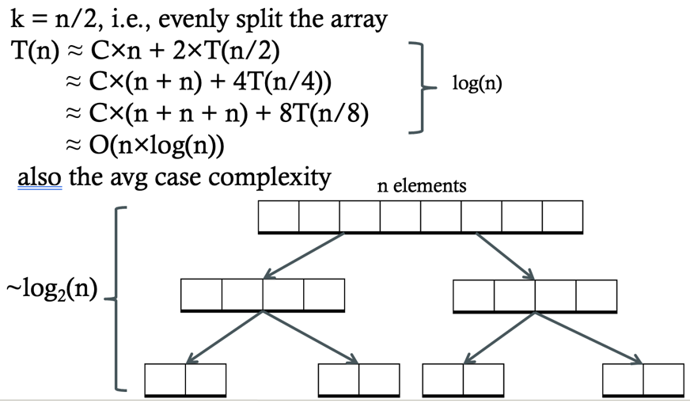T(n) ≈ C×n + T(n-1)

≈ C×(n + n-1) + T(n-2)

…

≈ C×(n + n-1 + n-2 + … 1)

= C×n×(n+1)/2 = O(n2)

Best/average case: O( n*log(n) )

Worst case: O(n2) 🡪 pivot far left/right

Example: **Binary Search on Sorted Array**

bool search (int first, int last, int key, int & index)

{

if (first > last) return false;

int mid = (first + last) /2 ;

if (key == a[mid]) {

index = mid;

return true;

}

if (key < a[mid])

return search (first, mid-1, key, index);

else

return search(mid+1, last, key, index);

}

Problem size: n, n/2, n/4,… 1 🡪 T(n) = C + T(n/2) = C + (C + T(n/4)).. 🡪 O(log(n))

Example: **Search on Binary Search Tree**

Worst case: A binary search tree completely unbalanced (only left/right subtree) 🡪 O(n)

Best case: O(1)

Average case: Every time, we are eliminating half of the elements 🡪 O(log(n))

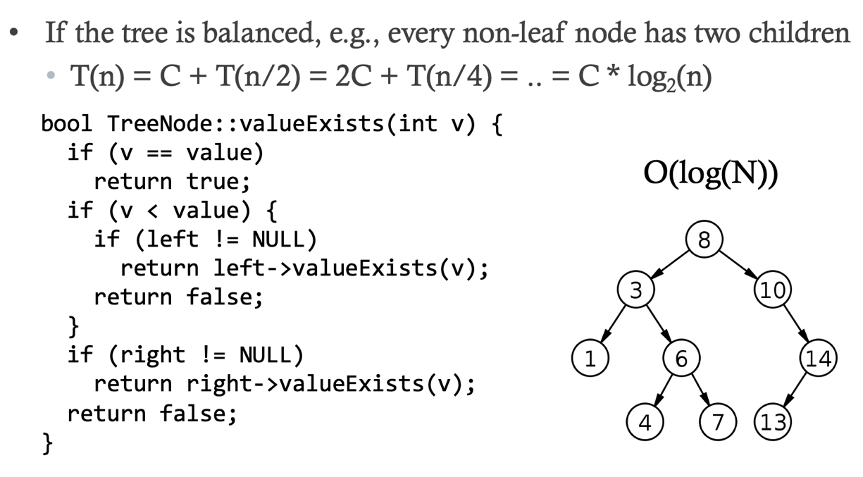

**Calculate complexity**

1. **Decreasing Functions T(n-b)**

|  |  |
| --- | --- |
| T(n) = C + T(n-1) | n |
| T(n) = n + T(n-1) | n2 |
| T(n) = logn + T(n-1) | nlogn |
| T(n) = C + 2T(n-1)  1 + 2 + 22 + 23 +… + 2k = 2k+1 - 1 | 2n |
| T(n) = C + 3T(n-1) | 3n |
| T(n) = n + 2T(n-1) | n2n |

T(n) = aT(n-b) + f(n) with a > 0, b > 0, and f(n) = O(nk)

* If 0 < a < 1 🡪 f(n)
* If a = 1 🡪 n * f(n)
* If a > 1 🡪 an/b * f(n)

1. **Diving function T(n/a)**

|  |  |
| --- | --- |
| T(n) = C + T(n/2) | logn |
| T(n) = n + T(n/2) | n |
| T(n) = n + 2T(n/2) | nlogn |

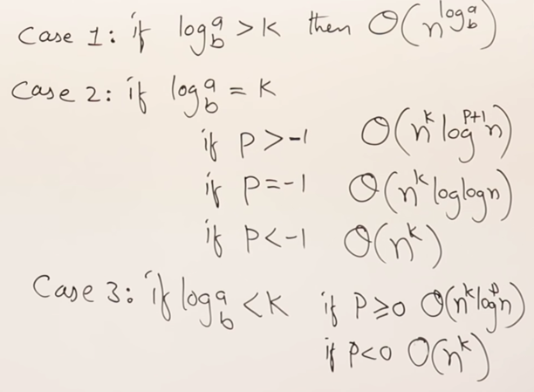 T(n) = aT(n/b) + f(n) with a >= 1, b > 1, and f(n) = O( nklogpn )

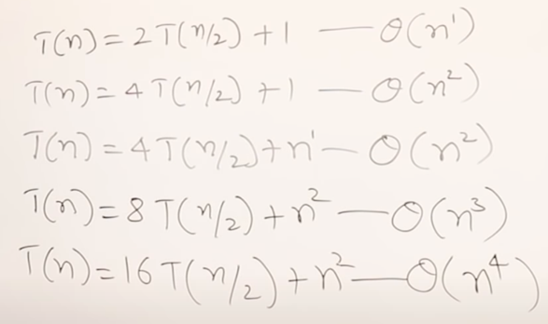

Case 1

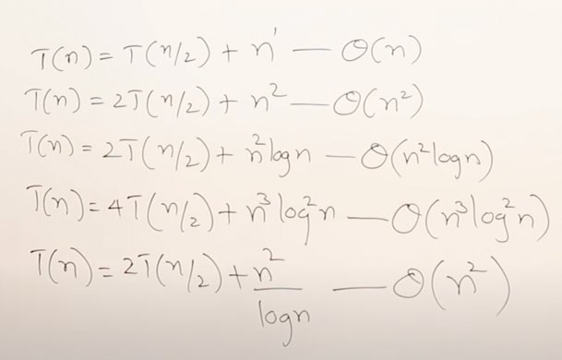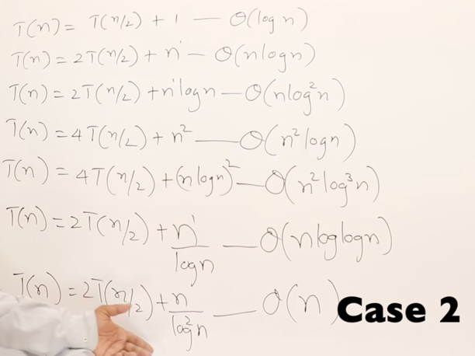

Case 3

**Series**

a + ar + ar2 + ar3 + … + ark = (for x < 1)

**Cache and Memory**

However, there are other concerns:

* CPU: speed in ns
* Latency of **CPU Cache**: in ns
* Memory: 100s ns

🡪 Sometimes, the constant C in algorithm is sometimes not important, that we can make it as large as possible to fit in the CPU cache! 🡪 faster

e.g. Matrix multiplication:

- Naïve version: a bunch of for loops

- When the matrix gets big, we may not fit the size in the Cache 🡪 If we really want to speed up matrix multiplication, we do multiplication in small regions of the matrix

🡪 Increasing big C 🡪 But gets hundreds of times of time optimization.

e.g. Sort:

Let's say we want to sort for an array. When array gets large, the array cannot fit in the cache.

🡪 If we have some sorting algorithm that works on small partions of the array (sub-arrays) 🡪 fit into cache

🡪 **Quick sort is actually faster than Merge sort, even though they have same complexity!**

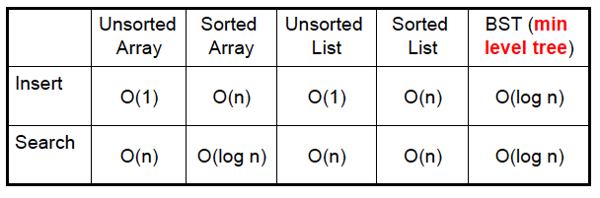

**Hash Table**

A data structure allowing finding a large collection of data.

* Hash Table provdies O(1) average performance on search/insert/deletion
* Stores data in a very large array
  + Typically 2x as many elements as the # of data elements to be stored
* A hash function:
  + input: **key** (relates to a **value** that gets inserted with the key)
  + output: **index** of the array (hash values)

For example, the hash function is implemented as **h(k) = k % (m+1)** (stores the value at the index that corresponds to the modulus of k)

**What if we try to insert 2 elements that have the same modulus? 🡪 **Collision!**

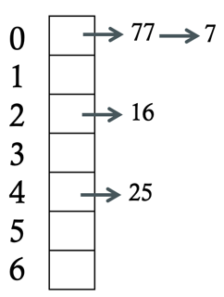 **Solving Collision**

1. **Hashing with chaining**
   1. Each hash table entry contains a pointer to a **linked list of keys that map to the same index**
   2. Therefore, the worst-case complexity for search is O(n) (traverse the linked list)
2. **Avoiding collision**
   1. Expand such that the average length of each list is 1 (distributed)
      1. Use more spaces (2x array elements)
      2. When collision occurs, store at the next empty position. Add metadata to signal that we are doing this (Google algorithm)
   2. Use smarter algorithm 🡪 usually involve multiply a large prime number
      1. e.g. h(k) = k * 31 % m

** Which way is faster? Expanding! Although it requires more metadata and more sophisticated implementations, the implementation is much more faster, due to **cache** instead of **memory** (required for linked lists)

**Lab 3 (string input)**

#include <iostream>

#include <sstream>

#include <string>

using namespace std;

int main() {

string line;

getline(cin, line); // Get a line from standard input

while ( !cin.eof () ) {

stringstream lineStream (line);

lineStream >> command;

if (lineStream.fail()) cout << "Error: invalid command" << endl;

else {

bool valid_command = false;

for (string keyWord : keyWordsList){

if (keyWord != "all" && keyWord == command){

valid_command = true;

break;

}

}

if (valid_command) executeCommand(lineStream, command);

else cout << "Error: invalid command" << endl;

}

// Once the command has been processed, prompt for the next command

cout << "> ";

getline(cin, line);

} // End input loop until EOF.

return 0;

}

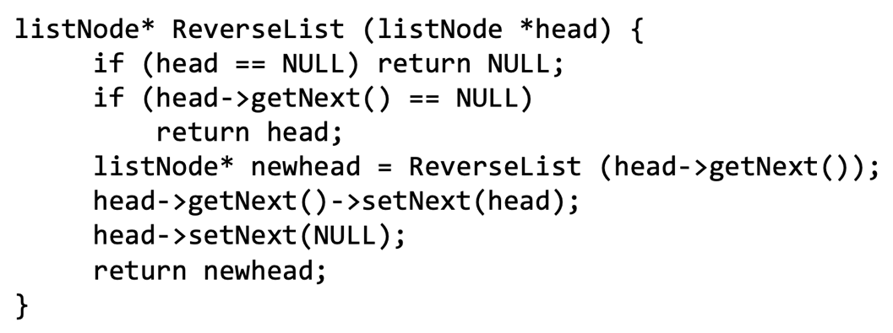**Reverse Linked List**

bool intValid (stringstream &lineStream, int num){

if (lineStream.fail()){

if (lineStream.eof()) {

cout << "Error: too few arguments" << endl; // Missing the int argument

return false;

}

else {

cout << "Error: invalid argument" << endl; // Type mismatch

return false;

}

}

char a = lineStream.peek();

if (!lineStream.eof() && a != ' ' && a != '\t') {

cout << "Error: invalid argument" << endl; // 10+ 21.4

return false;

}

if (num < 0){

cout << "Error: invalid value" << endl; // Negative value

return false;

}

return true;

}

**Check isBST**

